**Introduction to Case Studies in Business Analytics with Accenture - Fabrice Marque**

Hi, my name is Fabrice Marque.

I lead the customer strategy practice at Accenture for France, Belgium, and

the Netherlands.

And I sponsor the ESSEC and Accenture Strategy Business in Analytics chair.

Welcome to Case Studies in Business Analytics with Accenture.

In this MOOC, you will have the unique opportunity to learn from some of

our managing directors who are analytics experts and

who will walk you through real case studies in eight different industries.

Play video starting at ::42 and follow transcript0:42

You will be exposed to the business challenges that global companies

are currently facing and

understand how they leverage business analytics to solve them.

Play video starting at ::53 and follow transcript0:53

From financial services to telecommunications,

from media to transportation, many industries are being digitally disrupted.

New entrants with innovative business models are transforming the environment

and make it more competitive.

Behavior, also, evolving as customers expect the experience

to be continues, cross channel and customized.

To be relevant in this new environment, companies need to leverage data to

understand what their customers want, and find new ways to meet their expectations.

Play video starting at :1:31 and follow transcript1:31

Together, we will follow the analytics journey of successful

companies and discover how Accenture ADM collect data,

find relevant insights, create actionable recommendations,

and at the end of the day, deliver tangible business value.

Play video starting at :1:53 and follow transcript1:53

I believe that after exploring those real case studies,

you will fully understand how to leverage business analytics to create value

in the actual business environment.

Play video starting at :2:5 and follow transcript2:05

This MOOC should also prepare you to the Capstone project of the strategic

business analytics personalization in which you

will have to create value on your own from available data.

I hope that you will enjoy this MOOC and that it will help you go

beyond theory to become a real data driven, strategy focused manager.

# Market trends and key challenges in Analytics - Mickael Svilar

Hello, my name is Michael Svilar.

I lead Accenture's Data Science Group, globally.

Play video starting at ::14 and follow transcript0:14

Well there's two major market trends that we see in the analytic space.

One is the Internet of Things, and the other one is the growth of platforms.

And they're related.

But they're really changing the way we do our business.

With the Internet of Things what we see happening is that with all of the devices

being created, that we need to actually change the way that we do analytics.

In years gone by, analytics talent worked one on one very individually with

the statistical model and algorithm.

In the new world with the Internet of Things and

the desire to put the analytics out on devices, we're going to be, our analytics

talent there's going to have to start working in an area where they're building

systems to build algorithms versus building each algorithm individually.

Platforms is also a big change.

What we see with platforms is really about making our data and

our analytics at a larger scale in a broader way, where we can leverage them to

help drive business value by helping our clients take action from the analytics

that we do versus just reporting out in a PowerPoint or something like that.

The key challenges for the business I think are two-fold.

One is talent it's really hard to acquire top analytics talent and keep and

nurture and grow them.

And it's something that we do well at Accenture, but

a lot of our clients are struggling with.

That's a key one that we really focus on a lot.

We are able to provide a career path for

our talent, which I think a lot of companies who work in this area are trying

to build analytics team are struggling with.

The other areas, as I mentioned around the trends is the rapid change

of what's happening in the platform space.

That data costs are dropping dramatically.

That data went down in price about 80% last year and it continues to drop.

And then also the amount of data that's being created.

This is caused a dynamic change in the way that

analytics is done in the analytics business.

And to be quite honest, keeping a business up, with all the changes,

the rapid changes that we see in the marketplace, is really a challenge for us,

and I'm sure a challenge for companies, too.

# Why is Big Data really big? - Nicolas Glady

Hello, my name is Nicolas Glady.

I'm professor at the Essec Business School and you may have seen me in the MOOC,

Foundations of Strategic Business Analytics.

Business analytics applications have been around for many, many years.

As you have seen during the other modules, finding groups within data or

doing regressions are [INAUDIBLE], that are well recommended.

And from CRM to operation management, data has been used for

improving the performance of many businesses since at least the 90s.

So is big data really new?

Is the revolution some people claim it is?

I try to explain to you that there is something fundamentally new

in the phenomena we are observe in this video.

And that it's, therefore indeed, a revolution.

Play video starting at ::56 and follow transcript0:56

Let's take a very concrete example with CRM, customer relationship management,

in the context of a telecom service provider.

Like AT&T, for instance.

And let's imagine that you're interested in four individuals.

The presidential couple, President Obama and the First Lady, and two others.

Let's imagine Felix and his [INAUDIBLE].

These individuals use their phone and hence make calls or transactions.

With a telecom company, for a long time, these companies have been collecting data

about their customers and their transactions.

And so, one of the most classic ways to apportion CRM would be then to collect

a data set with three volumes.

Recency, frequency, and monetary.

One, recency means, how recent was the last transaction?

[INAUDIBLE], two frequency means, how often the individual makes a transaction.

And three monetary means,

what the average transaction value is in dollars, for instance.

It is the very well known RFM data stracture that

will allow marketers to perform RFM segmentation.

And then conduct some specific targeted market actions like course selling or

customer contention for instance.

Play video starting at :2:8 and follow transcript2:08

Moreover, we can see that the data is created and collected and

centralized by the company in a well structured way.

Play video starting at :2:17 and follow transcript2:17

In the years 2000, two phenomena appeared.

What was then called the web 2.0 and social networks.

With web 2.0, anyone could generate content and share it on the web.

The data generation process was decentralized.

It can be pictures, for instance, like the Four More Years picture

of the presidential couple that was taken after the reelection.

Play video starting at :2:40 and follow transcript2:40

Or it can be YouTube videos from famous YouTubers like PewDiePie.

Play video starting at :2:45 and follow transcript2:45

Even your auntie or your grandmother can have a cooking recipe blog nowadays.

And this explains the variety of the very famous 3Vs of big data.

because the source of data can now be anything and in any format.

This is explained by the fact that the data is user generated, and

not only company generated anymore.

This is typically unstructured data like pictures, videos, or

text because it doesn't, for instance, have a predefined format or

data model like an RFM database could.

After web 2.0, the second phenomenon is the central role of online

social networks in these dynamics.

A picture, video, or blog content could be exchanged over networks like Facebook,

Twitter, or Tumblr for instance.

And this explains the velocity, the information

is exchanged faster than before, and the volume of the 3Vs of big data.

The volume may even be explained mathematically.

If you're interested about storing information about an individual,

the quantity of data stored will be proportional to n.

But now if you're interested in the interactions of those individuals because

you know it's better to target customers like PewDiePie for instance, you will

generate data about the connections and not only the individuals anymore.

And if you have n notes in a network,

the number of possible connections is n times n minus one.

So it's similar to n to the square.

It's a quadratic relationship between the number of individuals in a network and

the data generated about their exchanges.

This [INAUDIBLE] calculation explains in part the volume of the 3Vsf.

Before we had data generated by companies that was structured, and

we could have thought to produce reports only once in a while.

Like every week, a month, about our customers.

Now, days of evolution happens.

The data is generated by the users themselves, and in real time.

And can be anything.

Text, pictures, or videos.

Strictly speaking, this is indeed a revolution.

UGC, user generated content,

places the individuals at the core of the data generating posts.

Hence at the center of a business analytics [INAUDIBLE].

Now, that doesn't mean that all of the applications you encounter will

be dealing with [INAUDIBLE].

As a matter of fact, in the last five years,

most business applications are still using classic types of structured data.

But this shift towards more customer centricity however, is a trend,

that is more and more present.

And when you're dealing with strategic business analytics,

using user generated data or not, you should always place the individuals,

customers, consumers, or even citizens are a the center of your analysis.

# Winning in Digital: Powered by Analytics - Jean-Pierre Bokobza

I'm Jean-Pierre Bokobza and I am the Senior Director with Accenture.

In charge of television and market in Accenture Digital.

It's fantastic to be here with you and present what we are doing with.

I can honestly say that I've never been more excited about what's ahead of us

in the market.

It's a fantastic time to do what we do and to talk about digital.

Play video starting at ::29 and follow transcript0:29

Let's get started.

Before doing this,

I think it would be interesting to provide you with some perspective around digital.

And to see our analytics is imperative to the digital transformation

we are going through.

I wanted to bring it a little bit to life.

Work you through what it means and

give example of what is happening in the marketplace.

Let's start by understanding what digital is.

Most of us would say social media.

The warming news of social media can be seen by some of these figures.

Every minute 2.5 billion people are connected to the internet and interact.

They do four million searches on Google plus 400,000 Tweets and

do 3.4 million likes on Facebook.

When most people think about digital they think about internet or the tablets or

the communication device that they are bringing with them everywhere.

The interesting part is that the number of devices is exploding.

It's not just about this form factor, which we use to communicate.

It's all sorts of different devices which are built into our kitchen, our homes,

our environment.

Each of those devices becoming smart,

they are becoming capable of absorbing information.

Something was going on around then.

Responding with realtime analytics and changing the way people worked and live.

To connect billions of sensors to all these devices,

to all these people who were connected to the web.

To public APIs, to all these apps that generate exabyte of data per month.

Requires sophisticated and complex platform and the ability to use values

mathematical models to extract value from the data generated.

And generate outcomes.

You can see that the emergence of data created opportunities

to manage relationships with customers and it's employees.

It's also created new business model and the ability to predict events and

create analytics.

Play video starting at :2:12 and follow transcript2:12

Multiple formats, multiple source, multiple utilization, and

the ability to regulate structured and

unstructured data allows the better prediction of consumer behavior.

Play video starting at :2:22 and follow transcript2:22

Accenture sees two primary aspects of digital.

Play video starting at :2:27 and follow transcript2:27

They first focus on digital customers, channels, and markets.

This is about designing and enabling important channel customer experience,

digital customer interactions,

digital sales, and digital channel distribution capabilities.

The other aspect of digital focus on digital enterprise.

This is about enabling companies to be digital by enabling new ability model and

business process, connected platforms, analytics, and

collaboration capabilities to enhance productivity.

We see this being applied across industry areas such as smart water, smart building,

smart cities, digital plans, and many other Internet industrial applications.

The second aspect is around Go Digital.

By letting digital to expand their go to market activities and

create new services and business models.

Digital has fundamentally changed the way organizations and governments operates.

From how they interact we interact with our customers, citizens, and supplier, how

to manage your employees, differentiate themselves in the market and as they grow

their enterprise to become more profitable and expand their footprint.

Play video starting at :3:35 and follow transcript3:35

This has created an entirely new set of opportunities and challenge for clients,

ones that industry analysts estimate to be about $14.5 trillion per year.

Our mission at Accenture is to help our clients to take this opportunity and

be key player to change the way the world works and lives.

Play video starting at :3:54 and follow transcript3:54

Now how do we do that?

Step one, we have to help them imagine what they could do.

It's just about doing things differently, it's about doing different things.

It's imagining new ways to create the customer experience.

The best type of experience, a student learning experience,

[UNKNOWN ]experience and to outcome at scale.

It's not about creating a pretty app on my iPhone,

it's about changing how people experience life and

of the experience will deliver in a much more impactful way moving forward.

It's a paradigm shift.

So as we talk to clients we make two simple questions.

The first question is how to there engage with people who are happen to be using

digital capabilities to interact with our organization.

Of course they are not only interacting with the store channel, so companies have

to think about a strategy that includes a multi-channel customer experience.

They have to understand where people are starting conversations,

where they are interacting with the company and all the customer support.

At Accenture we have capabilities and

assets that we stitched together in order to enable that multichannel customer

experience across multiple geographies, industries experiences, etc.

The second thing is how the enterprise can fulfill their mission more effectively.

Play video starting at :5:13 and follow transcript5:13

The enterprise could be the city of Chicago trying to serve it's citizens and

to think about how they can do better job providing services to you, the citizen.

Play video starting at :5:23 and follow transcript5:23

It could be a hospital trying to create a better patient care.

It can be a commercial enterprise trying to transact business.

But all of those people have got to understand

how these digital technologies impact their corporate services.

When Accenture talk about digital enterprise,

it means that we focus on transforming business processes leveraging

digital technology to enable new operating model, connected product platforms,

analytics, and collaboration capabilities to enhance.

Productivity.

It could be intelligent everything, ie smart grid,

smart water, intelligent pipelines, connected cars.

Everything that drives a connected world across business functions

including finance, HR, operations.

So we talk to clients about a broad range of topics, but

all of those conversations come back to all they can change.

As a way the world works and lives.

I know digital is changing the world, accepting at scale,

at an ever increasing pace.

And so, reguardless on where you look as a picture, what kind of measurements you

take, and what you are going to see is that it's exploding.

Play video starting at :6:30 and follow transcript6:30

Why digital is changing the world.

Every aspect of our lives is changing and is touched by digital interactions.

We shop online, we learn online, share intimate details of our lives online.

We take our exercise and those reserves online.

We pay and receive payment online.

Digital doesn't reflect what we do, it reflects who we are.

# Big data & predictive maintenance in the Utilities sector - Rohit Banerji

Hi I'm Rohit Banerji.

I'm a senior manager based out of London.

I'm Accenture's business lead responsible to develop big data analytic platforms for

the resources sectors which includes utilities, chemicals,

mining and oil and gas.

Our client Thames Water, which is the largest water company in the world,

have faced unprecedented challenges in their business environment.

Two of the most impactful changes have been constraints on capital following

the recession, and the imminent market reforms which will open the whole sector

up to create a competition in two years.

Play video starting at ::47 and follow transcript0:47

The first change drove the need to do more with less.

Whereas the second change market reform needs the company to

compete in the market on various spots of their business.

And that requires greater insight, it requires greater data and

it requires greater facts on ground, like network performance.

How does it affect their customers?

While [INAUDIBLE] explored every avenues

such as changes to maintenance and organization redesign.

Accenture was specifically asked to advise on how Thames Waters' existing estate

of data and legacy systems could be better utilized.

Play video starting at :1:28 and follow transcript1:28

A detailed analysis of what Thames Water wanted, and

what they already had, revealed a potentially game-changing opportunity.

And that game-changing opportunity was that Thames Water had enough

data to support a hugely more efficient system operating model.

A system operator model means that operational and investment decisions

are optimized to account for the interplay between assets connected in the network.

And these can be hugely complex for a water network.

Fundamentally, it means that decisions are made faster, more locally, and

more based in fact, which gives it the agility and

efficiency that the company is looking for.

Play video starting at :2:11 and follow transcript2:11

It took us a full year to help Thames Water develop a coherent

technology structure, bringing together operational technology.

Play video starting at :2:20 and follow transcript2:20

Formed of sensors, telecoms, automation systems and information technology,

which includes the usual culprits like ERPs, geo-spatial systems and

hundreds of other software which is typically used by a water company.

Play video starting at :2:35 and follow transcript2:35

It's then taken two years to prove that it can actually be done on ground.

Play video starting at :2:40 and follow transcript2:40

Huge amounts of data had to be brought together and this hadn't been done before.

Accenture's big data platform was fundamental to making this happen

by allowing Thames Water to integrate their data without re-engineering systems.

Play video starting at :2:54 and follow transcript2:54

All massively improving their data,

both of which would have been unaffordable and probably a non-starter.

Play video starting at :3:2 and follow transcript3:02

The results of the trials were spectacular.

Various spots of the business saw their data visualize in one place for

the first time left for sewage to spill.

Reservoirs draining faster than expected and

potential supply destructions triggered preventive action.

Saving customers a lot of trouble.

Play video starting at :3:26 and follow transcript3:26

As you can expect with any paradigm shifts,

success depends more on people than technology.

Play video starting at :3:32 and follow transcript3:32

Working with rich, near real time insights is an entirely different culture.

The challenge now is for temps water to follow through with their convictions.

The conclusions from a recent interaction between Thames Water and a global mining

company on a similar journey pretty much sum up the opportunity.

Play video starting at :3:52 and follow transcript3:52

Number one, manage the asset system rather than the asset.

Play video starting at :3:56 and follow transcript3:56

The approach has typically delivered financial benefits of over 15%,

regardless of the sector it was implemented in.

Play video starting at :4:5 and follow transcript4:05

Number two, success is 90% people change and 10% technology.

People change only comes about by sticking to the plan and following through.

Play video starting at :4:15 and follow transcript4:15

Everyone should be able to see that contribution and

what a good day's work looks like.

Play video starting at :4:24 and follow transcript4:24

Finally, don't wait to use to your data.

Emerging big data and

Internet of things technologies have unlocked data silos like never before.

However, for

organizations already in business, it is fundamentally a people change.

And therefore, a leadership challenge.

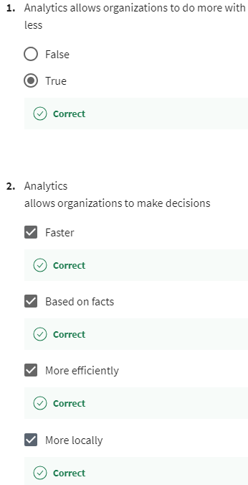

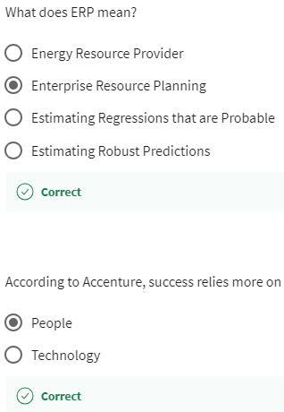

# Big data & advanced analytics in the Communications industry - Cian O’Hare

Hello, my name is Cian O'Hare and I'm a Managing Director at Accenture Digital.

I lead a number of exciting engagements with our clients in the UK and

Ireland in the big data and advanced analytics domain.

The case study I would like to share with you today

is from a global communications provider.

This company operates in over 26 countries and

has an excess of 400 million customers across the globe.

It serves both the consumer and enterprise sectors.

The company wanted help in creating a big data capability as a strategic asset.

They recognize the opportunity to derive significant commercial value from

analytical insight by combining and

processing vast quantities of structured, unstructured, and third party data.

The main challenges the company face could be split into two.

Firstly, organization.

The current analytics organization was fragmented, didn't have the right skills,

and lacked a commercial focus.

Its main function was KPI and historical reporting.

It also lacked a cross functional approach to analytics and

operated very much in silence.

Secondly, technology.

There was a gap in the current technology to enable cost effective

processing of the data.

In fact, the company only processed less than 5% of the data that it generated

across its networks and systems.

This also required a shift in the traditional IT operating model of wanting

to control and limit an access to data, to an approach where data is democratized for

exploratory purposes.

The client has the ambition to deliver an incremental $500 million

of annual EBITDA in five years.

Accenture worked with a client to mobilize a big data program split into three

workstreams.

The first workstream was focused on organization.

This included designing a new big data and

advanced analytics organization that had a hub and spoke model across many countries.

The client is looking to build this team to 150 people over the next two years

focused on both hypothesis-driven and exploratory analytics.

The second workstream was focused on technical architecture.

Accenture helped to find a target reference architecture for analytics and

business information.

We also ran a selection process for a Hadoop distribution.

Following the selection of a Hadoop distribution, Acccenture deployed a number

of instances, as well as supported the load of data into these environments.

The data loaded into the network events, CRM, BI and marketing data.

And this was the first time these data sets were brought together.

The third workstream is where we work jointly with the clients to develop

analytical use cases.

These use cases were focused in a number of domain areas.

Firstly, customer analytics, where we combine network, customer, and

marketing data.

We then helped develop predictive models to correlate network events and

experience with churn.

We then extended this to include text data from customer care agent notes.

Mining the text data allowed us to start to build a view of the overall sentiment

of the customer, and provide a health score, and

likelihood of this customer to churn.

Having this information allowed for

the developer to proactive retention, cross sell and

up-sell campaigns that were launched across a number of outbound channels.

Secondly, fraud analytics.

Using advanced analytics techniques such as machine learning to understand

the likelihood of new customers not paying for expensive smartphones.

Play video starting at :3:14 and follow transcript3:14

Thirdly, network analytics.

Using predictive algorithms to detect faults before they occur on the network.

Play video starting at :3:20 and follow transcript3:20

This has a net result of improving the customer experience and

significantly reducing costs from unplanned maintenance,

calls to customer care, and customer churn.

These used cases have recently been launched as production

marketing campaigns.

Already the results are very positive with many millions of

dollars in benefits being realized.

One of the main aims is to reduce network experience related churn by 10%.

This will have a significant impact commercially

as well as delivering a better experience for the end customer.

I hope you found this case study interesting, and

it is one we're starting to see play out across the communications industry,

where organizations that leverage new tools, techniques, and

their data as a strategic asset is helping drive significant competitive advantage.

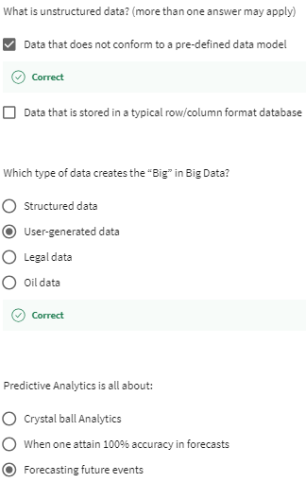

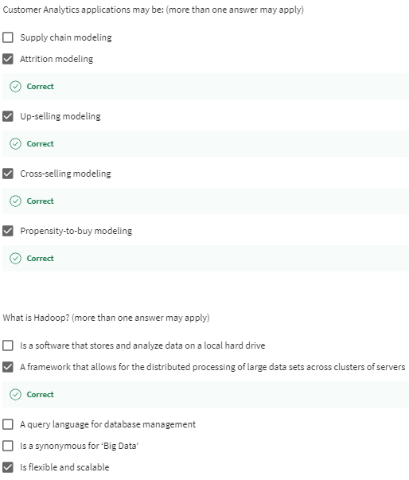

# Advanced Analytics in the Public Service - Christopher Gray

Hi my name is Chris Gray and

I look after analytics in the public service here at Accenture.

Today I want to talk to you about some of the ways that we're using advanced

analytics to help our public service clients.

Play video starting at ::23 and follow transcript0:23

The public service around the world is facing a number of challenges, not least

of which the budget cuts that have been imposed on it over the last few years,

as well as an aging workforce and an inability to replace staff as they leave.

Play video starting at ::37 and follow transcript0:37

There is also an increasing focus and a renewed focus on fraud, waste, and abuse.

And ensuring the financial integrity of our tax and our welfare systems.

Play video starting at ::50 and follow transcript0:50

So the case study I want to talk to you about today is with a major European tax

agency.

An agency that we have been working with, particularly over the last three years,

in applying advanced analytics to their core processing operations.

Play video starting at :1:5 and follow transcript1:05

This client was facing a significant budget pressure,

up to 20% year on year reductions in their budget.

Which was leading to almost a 50% reduction in some of their front

line staff.

Play video starting at :1:17 and follow transcript1:17

The staff were working and dealing with tax exceptions.

So every year people were filing their taxes.

And business rules would generate exceptions that needed clerical

intervention.

They were also responding to telephone calls and customer post queries.

Play video starting at :1:34 and follow transcript1:34

Effectively, we worked with them and along side our business process re-engineering

colleagues through a three phase program to identify savings.

Play video starting at :1:45 and follow transcript1:45

The first area was in opportunity scan,

Play video starting at :1:48 and follow transcript1:48

the second area was subset of proofs of concept, and

then the third area was moving very much into delivery and ongoing operations.

Play video starting at :1:58 and follow transcript1:58

At the opportunity scan phase,

we were using analytics really just to understand what was going on.

Can we understand the micro segments and the clusters that existed within the work?

Play video starting at :2:10 and follow transcript2:10

Could we understand what was happening over time with those cases

in terms of the work flow throughout the year?

Play video starting at :2:17 and follow transcript2:17

Once we had this segmentation in place we could actually start to understand and

identify areas of opportunity.

Which were cases that if we attacked them were taking a huge amount of time to deal

with and perhaps deliver some savings for us.

Play video starting at :2:31 and follow transcript2:31

It was at that stage we could then move into proof of concept.

Play video starting at :2:36 and follow transcript2:36

And at the proof of concept phase we were using a variety

of advanced analytics techniques to really understand what was going on.

Play video starting at :2:45 and follow transcript2:45

We were using, again, microlevel segmentation to break workloads down

into their smallest level of component.

And really understanding if we could differentiate and

optimize the business processes for each of those small segments.

Play video starting at :2:59 and follow transcript2:59

We were using predictive modeling to understand what was the likely outcome

having worked a case.

So if we could predict the outcome,

that had the opportunity to save certain clerical steps and

potentially identify whether there was any value due at the end of the case or not.

And that would lead us to put automation in place.

We did root cause analysis, understanding if we could trace back to why the case

existed in the first place, and actually by attacking that root cause,

could we start to save the case from ever being generated in the first place.

Play video starting at :3:34 and follow transcript3:34

We then did data mining and data matching.

Using different data sources that perhaps hadn't historically been used

to identify new sources of yield.

Perhaps somebody hadn't told us of any additional income that they had.

Or perhaps we saw some anomalies in the way that people were using some of

their allowances and perhaps not paying all of the tax that was due.

We brought all of those together in a model office, testing new ways of working

and actually adjusting the models and the business process as we went through it.

Play video starting at :4:6 and follow transcript4:06

And only once we were happy, did we then move into delivery.

Play video starting at :4:11 and follow transcript4:11

As I look back now at the end of the program,

we delivered millions of dollars of efficiency savings to the client.

Effectively eliminating over five million items of work from their ongoing year on

year work queues.

Play video starting at :4:25 and follow transcript4:25

We also identified hundreds of millions of dollars of increased tax yield

that will now be coming into the tax agency on the year on year basis.

Now they have been able to use those data sources and

put on matching rules in place.

Play video starting at :4:40 and follow transcript4:40

Effectively, we've helped position this tax agency so

that it's now in a position to be sustainable for the coming years.

As well as, providing them with approach and a set of a methodology so

they can continue to use and refine in the future.

As they no doubt continue to be under increased budget pressure.

We've also taken the opportunity to take the learnings from this case study and

apply them more broadly to our other public service clients.

Play video starting at :5:9 and follow transcript5:09

In the public service often the first area that people are worried about is,

how can I drive out efficiencies.

They often have more work than they have people.

So actually how can we start to take some of that pressure off them?

We've also continued to use the learnings around fraud, waste and abuse, and

apply those to a variety of clients, not just in the tax sector, but

also in the likes of customs agencies or welfare agencies.

Play video starting at :5:37 and follow transcript5:37

What's been clear to me as we've gone through this is being able to marry

advanced analytics with business process reengineering.

And really working at the ground with our clients,

we're able to deliver significant and sustainable business change.

Thanks very much for your time.

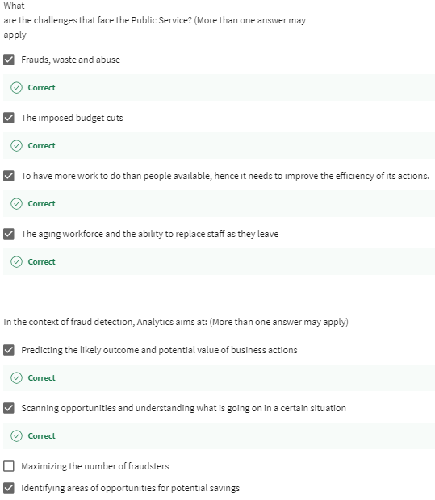

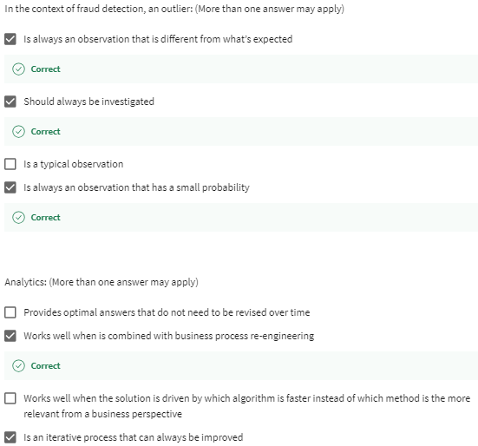

# Wrap-up: a conceptual framework of the applications of Big Data Analytics - Nicolas Glady

This MOOC aims at exposing you to examples of applications using

data to create values for companies.

The MOOC will also prepare you for the capstone project.

Since traditional business analytics cases, such as segmentation or

targeting have been widely discussed in the previous videos.

I'd like to spend some time discussing the applications

that are specific to this new type of data, which is user generated content.

That is data generated in a decentralized way by users or

devices and exchanged over networks.

We therefore, have two resulting axes of analysis.

The type of network, human to human, human to machine or machine to machine and

the proximity with the end user, front-end, middle-end and back-end.

First, let's discuss the type of networks we have.

Human to human is the type of network we all know very well between people.

This allows you, for instance, to do customer analytics like targeting,

costs, up sell or attrition modeling by collecting data about what people like or

what they did in the past.

This is typically used for making recommendations, for instance.

If I know that people at our are connected to you, purchased or liked,

especially positive in the past.

There's a high probability that you will like it as well,

then we add the machine to machine networks.

Machines are objects that are connected to each other.

This actually constitutes the biggest set of big data.

Let's just think of an example of a household with a couple and a child.

You have a network of two humans there.

But in the same house, you may have several smartphones,

smart watches, smart scales or video game platforms and

a whole bunch of connected objects like WiFi speakers.

Imagine, that buttons or eco's and the likes.

That's a lot more than only TV and videos.

And if we look at the whole planet where we have a network of 9 billion

individuals compared to the potential of machine to machine, this small.

This is because the M to M network has a potentially infinite

number of objects and it's virtually limitless.

A very famous example of applications come from GE and the enzymes they make,

where all the devices have kettles and are connected to each other.

It tells GE to monitor the developed consumption or

the probability of failure for certain element in real time and

make energy saving, as well as productive managements.

Finally, we have the human to machines connects,

which connect H to H and M to M networks.

This constitutes all interactions between people and objects.

For instance, the wearable technologies and the internet of me.

This allows you to track your spot performance in real time.

The number of steps, your heart rate and many other such biometrics.

If you're interested in sporting performance or just losing weight, you're

probably already aware of such items, like Fitbit or even the Apple Watch.

But where the applications are the most interesting in this field is

probably in health and we come back to it during our next module.

You then have the second axis, which accounts for

the proximity with the end user.

The front-end and middle-end applications are obvious and

have already been discussed before in this specialization.

Front-end applications allow you to monitor the activities along

the different types of networks and middle-end applications

allow you to use the data generated to optimize existing processes.

This is what allows analytics to make decision faster, more locally,

more efficiently and above all based on facts.

The third type of application is really interesting and

it's really what makes big data novel.

It's what they call the back-end types of applications,

which allowed data analysts to identify and design new applications.

Thanks to big data, we can now observer and

hence analyze what was before outside the scope of companies's organizations.

This is because the data is generated by the users and not by the company,

as it was previously when outside of its control.

Hence, we can observe or cline or even forbidden or illegal behaviors.

Before, anything that was not allowed by the company's system could not have

been observed by the transaction system, because it was simply not possible.

If it happened, it happened outside the system and no data was collected.

Now with user generated data, we can observe what people want or

do even if we do not allow it to paraphrase a very famous sentence.

Big data allows us to observe what we don't know,

we don't know and this is really interesting for many applications.

Marketing, obviously, where we can identify new needs by listening to what

people say they want on blogs or forums, but those are for fraud detection or

even national security.

In those contexts and outlying observation may be very interesting to study and

should always be investigated.

Big data by its very nature of centralization and by the fact that it's

user generated unveils many behaviors that were previously totally and

observable by companies and organizations.

# Peer-graded Assignment: Predictive maintenance for a water supplier : Internet of things

DeadlineJan 7, 11:59 PM PST

i

It looks like this is your first peer-graded assignment. [Learn more](https://learner.coursera.help/hc/articles/208279926-Submit-peer-reviewed-assignments)

**Ready for the assignment?**

You will find instructions below to submit.

1. [**Instructions**](https://www.coursera.org/learn/case-studies-business-analytics-accenture/peer/tO6h2/predictive-maintenance-for-a-water-supplier-internet-of-things)
2. [**My submission**](https://www.coursera.org/learn/case-studies-business-analytics-accenture/peer/tO6h2/predictive-maintenance-for-a-water-supplier-internet-of-things/submit)
3. [**Discussions**](https://www.coursera.org/learn/case-studies-business-analytics-accenture/peer/tO6h2/predictive-maintenance-for-a-water-supplier-internet-of-things/discussions)

You are working in the business analytics team of the main running water supplier of the city. Your current project objective is to build a new data-based framework to optimize your business, in particular in terms of control and maintenance.

You need to prepare a data collection plan and present it to your management. This assignment aims at preparing such a report.

Here are some key questions that could be addressed (but feel free to raise any other one) :

1. Data definition: what kind of data will you collect? Be as specific as possible in the definition of the variables of interest (the indicators).
2. Data source: where will you collect data? With which devices?
3. Data usage: how will this data help you to improve your ability to do business? What are the expected use cases?
4. Data value: summarize how important this data is for your project on a scale from 1 to 5.
5. Data availability assessment: assess how easy you think the data can be collected and prepared for analysis on a scale from 1 to 5.
6. Data priority: in consequence, rank the first actions to take in terms of data collection, preparation and analyses.

### **Grading Criteria Overview**

This will be a peer-evaluation: you will evaluate the other students of the course (and you will be evaluated by other students.) The grade is on 20 and is based on clarity, innovation, whether the indicators are defined well enough, is the data collection process defined well enough, is it visual, is the promise for value good enough?

You have to prepare a 5 slides document in a PDF format

The rubric is as follows:

1. How clear is your presentation? The grade is on 3 (0 very unclear, 3 very clear)
2. Are the proposed use cases innovative? The grade is on 2 (0 not innovative, 2 very innovative)
3. Indicators: are they clear and relevant? The grade is on 5 (0 not clear and not relevant, 5 very clear and relevant)
4. Can you produce those indicators with the data collection process that is described? The grade is on 5 (0 the data collection process is not clear or not realistic, 5 the data collection process is clear and realistic)
5. Is the presentation visual? The grade is on 2 (0 not visual, 2 good visuals)
6. Is the promise for value of the use cases good enough? The grade is on 3 (0 no or little value, 3 high and convicing expected value.)

<https://coursera-assessments.s3.amazonaws.com/assessments/1703106446205/88da2070-dbca-462f-b417-e687a124ea50/EC.pptx>

<https://coursera-assessments.s3.amazonaws.com/assessments/1703318453800/407811ee-ba31-479f-80ea-a21f32b703fc/Water%20Management%20Report%20assignment.pdf>

<https://coursera-assessments.s3.amazonaws.com/assessments/1703588409001/53c48167-396b-46da-9a18-29a6a483f9bc/Predictive%20maintenance%20for%20a%20water%20supplier.docx>

<https://coursera-assessments.s3.amazonaws.com/assessments/1694356663990/2be61474-adca-4917-9417-29558bbe7c29/ess.docx>

# Context - Christine Removille

Good morning, good afternoon everybody.

I am Christine Removille.

I am leading digital marketing for Accenture to Europe and

and I used to lead Accenture Analytic in France, [INAUDIBLE] in Belgium.

As part of this role, I was leading a major

digital transformation at a client called Canal+.

Canal+, for those of you who don't know about it.

Canal+ is a French TV player part of the group.

And Connect Plus is providing movies, video on demand, and

mainly or content and services to the TV viewers across devices.

Whether it is TV, whether it is mobile, whether it is iPad,

and other devices that end consumers are looking at.

So when we started engaging with this client, it was actually in the year 2008,

and at the time Accenture used to implement

large ERP transformation, many on the back office side.

And then we started navigating to the front office.

So talking to the business owners.

And we met with the business owners,

we realized that there are a couple of issues that CANAL+ was facing at the time.

The key issues were there is

an ecosystem of a TV environment is totally transforming.

So people like yourself are not only watching movies and

programs or shows on TV anymore, you're also watching it through various devices.

Play video starting at :1:50 and follow transcript1:50

We saw also with expansion of non-paid TV and we need to know about Canal+ today and

what else is the times TV, a paid TV station.

So we see the explosion of access to programs for free.

Play video starting at :2:6 and follow transcript2:06

And also at the time, consumers have been tremendously changing.

So you see a lot of change.

People change TV programs and then to be a lot less loyal to TV programs and

TV channels today than they used to be in the past when they had a lot more

Play video starting at :2:25 and follow transcript2:25

limited access to TV and less choices when they are approaching TVs and content.

So we came into the environment to help address those key issues for the client.

Play video starting at :2:40 and follow transcript2:40

And the approach we took is actually very simple and straightforward.

So first of all, we explain to Canal+

that analytic need to come at the core of the enterprise.

So, a need to become like the backbone of the enterprise.

Play video starting at :3:5 and follow transcript3:05

Reason being, that if Canal+ wants to be able to increase their sales,

increase our shelf market, increase our customers stickiness,

they need to better understand the consumers.

Play video starting at :3:19 and follow transcript3:19

Once we better understand the consumers, what they're looking at,

what they want of TV programs, then we analyze those data,

we make some inside out of it, recommendations KPI and

then we make sure that we provide the right content, the right segment,

to the right consumer, at the right time, according what he is or she is looking

at or, actually wishing to get tomorrow, but not being aware of it today.

To do this project, Accenture wrote five capabilities.

Number one is marketing.

It's critical that to do this anality transformation,

it's critical we understand marketing.

We understand the end consumer.

We understand what it takes to increase customer loyalty.

What it takes to have a new consumer to canal+, what it takes to

make sure the consumer is not leaving via tv program and so on.

So you need to understand marketing and we brought these expertise to the project.

Certain expertise is advance analytics so in house we have set stititions.

People who have mathematical degrees and

are able to build to transform the data into inside that we can act on.

Play video starting at :4:39 and follow transcript4:39

The third capability is data management.

So you can imagine if you want to capture consumer and behavior,

you need to be at each of a touch point of a consumer interaction,

not only with your company, you have to in this case, but

also the consumer touch point within his own life.

So I'm the consumer.

What did I do today?

Which would impact the TV program I'm going to watch tonight?

What it is I have been Googleized on the internet,

which would impact whether I'm keen to watch rugby tonight or football tomorrow.

So what it is that I did in my daily environment, which would impact whether I

watch Canal+ on a [INAUDIBLE] TV channel, and I'm happy about it.

So the daytime management capability is important.

So in our team, we do have data expert.

People who are able to identify the data sources

because it's a multi-source environment.

People who are able to store data because of course, we need to

keep the confidentiality of those data, and that's a lot of data we need to store.

And people understand big data, so

you probably heard about big data technologies.

And for Canal+ we need to make sure we embrace all those data, we store them,

and we manage it in a technology which is all putting off so

it can all go into a big data environment.

Play video starting at :6:3 and follow transcript6:03

The fourth capability is around what I call Enterprise Architect.

Enterprise architect that is somebody who understand each of the key capability well

enough to guide Canal+ into the end to end transformation.

So, when the data manager need to talk to the marketing expert, when the marketing

expert need to talk to advanced analytic guys, so how does it all work together?

It's all the more like an orchestra chief, right?

So somebody who is really coordinating the different pieces of a puzzle.

And it's extremely important to have that in house,

to help Canal+ transform their program.

Play video starting at :6:42 and follow transcript6:42

The fifth capability, which is, of course,

a core of Accenture for is IT.

This program cannot happen without IT.

And of course, we have people who understand solutions in the market,

so we can test them.

Who understand new big data technologies.

Understand the cloud environment, and

all the technologies that we are using today, to make Canal+ a success.

So we have both five capability in house.

With your, the program manager.

And how did it happen?

So what where the various pieces

to make it a success because I tell you it is a success today.

We started in 2008, for a six year transformation,

and today the CEO himself called it a success.

# Solution and success factors - Christine Removille

We implemented five steps,

so it's easy.

If you want to remember the Canal Plus story, five, five, five.

In this case, 5 steps.

Step number one, we pull together what we call the roadmap.

So where it is we want to head in five years and ten years time.

What is the vision?

Where do we want to land?

First step, which I tell you is not always easy because you're going to see later

there is a lot of learning by doing.

Play video starting at ::36 and follow transcript0:36

Step number two, in a very agile environment, which is analytic and

when it concerns the consumer, we have to be agile because the consumer's changing.

New data sources, new environment, fast moving environment

in the TV area, everything we said before request agility in the approach.

So the step number two is piloting.

So what we did, is we took a sample of 100,000 people.

So 100,000 people watching TV.

Now this simple, we made tests.

So we capture their behavior and then we put some advanced on that,

some recommendations of this person should be watching this show tonight.

This person should be watching this program tomorrow and

his kids should be looking at something else.

So we put together some recommendation,

test it with the TV viewer and then draw recommendation.

Does it work or it doesn't work.

We did a pilot.

Once a pilot was successful, we went into the more industrialization phase.

Play video starting at :1:49 and follow transcript1:49

Usually, there is two types of industrialization we do.

Play video starting at :1:54 and follow transcript1:54

First type of industrialization is regarding the sample size.

So, we need to expand it to more people.

More from 100,000 people to about 6 million

interactions that Canal Plus has today, [INAUDIBLE] consumer.

So, we industrialize it by opening it to more people.

The second, of course, including big data technology,

and including everything we talked about before.

Play video starting at :2:23 and follow transcript2:23

The second industrialization is around the sources.

We realize that we need to understand consumer a lot better.

So not only use resources we have in house that can impress,

we use resources we have outside.

So resources, for example, from the call center,

if your consumer is going to call the call center, what it is he said, or didn't say,

or like, or doesn't like, I need to capture of his data as well.

Play video starting at :2:50 and follow transcript2:50

Insight about in a shop.

Okay, either consumer is going to buy something, so

how does it impact what he's going to be watching tonight on TV?

Advertisement, if he's looking at the banner ad on Internet,

he may be interested in looking at the food program tonight.

Because you saw an ad, which is about chocolate cake for example, right?

So we started including some over sources into a mix as part of

the industrialization process to make the recommendations smarter and

smarter every day and more appropriate to the end consumer.

So that at the end when you watch Canal Plus, it's not I'm going to watch TV.

Play video starting at :3:36 and follow transcript3:36

It is about I'm going to watch my TV.

Play video starting at :3:39 and follow transcript3:39

because I know that the TVs going to be adapted to what I like, what I want and

actually what I wish I had tomorrow.

Play video starting at :3:48 and follow transcript3:48

So those are the five steps of a transformation we had during the project.

And I'm happy to share with you probably the various challenges and

success factors to make this journey a success.

I would say the first challenge is to make sure that this analytic transformation

got the buy-in at the CEO level, because

everything I explained before, you bet you know how he's impacting large investment.

So I cannot work with a organization.

I cannot send this project to the IT only or to a business only or

to the head of analytical.

That doesn't work.

The CEO himself needs to engage in transformation and buy the project.

Play video starting at :4:38 and follow transcript4:38

So challenge number one is the CEO has to buy the project and

get the funding behind it.

Play video starting at :4:45 and follow transcript4:45

The second challenge is agility and innovation.

I can tell you that when we put together the vision, year one, very high level,

I can tell you during the course of six years, we made a lot of changes.

And agility was critical In the way we operated meaning,

I'm going to test this new idea.

I've got a new service, I'm going to test it.

I'm going to build some recommendation.

Does it work?

It doesn't work.

If it does, what do I change?

What do I not change?

A lot pilot, a lot of agility, a lot of prototype.

We've been building many, many prototype during this project.

So that we can test it.

It's not only about slideware It's not only about us doing some nice PowerPoint,

but how to do it.

It's about us doing it, prototyping it, see how it work, and

then make some learnings about it.

Agility is extremely important.

The third success factor is around innovation.

On this project, innovation during those six years was critical.

Play video starting at :5:46 and follow transcript5:46

What I mean by innovation,

I mean that six years ago we are not talking about big data.

Today big data is all over.

So how do I migrate all my IT infrastructure,

which was in a kind of [INAUDIBLE] standalone,

custom made IT into big data, open source, cloud environment technology.

So this migration is an example of innovation.

The other part of innovation is regarding marketing.

So, how do I use those fantastic consumer insights,

something like Amazon does today, right.

Amazon is using your consumer insight about you reading books and

doing other things.

So they're using it for many purposes.

So, how do we use TV viewing usages for other purposes.

So we had some brainstorming sessions with marketing, with consumers, ourself, and

brought some new ideas about how to use those consumer insights into new areas.

For example, should we develop new programs?

So we have new themes or categories of program to address the consumer demand.

Should we change the way we interact with consumer.

Maybe people don't want core centers anymore.

They want avatar.

So how do I make my consumer journey evolving.

For example, once I have a household,

I know they're going to have children, right?

So how do I change my TV recommendation once I know that they

are about to have children of the age of zero, five, and six,

potentially all of them being in front of their screen?

Play video starting at :7:28 and follow transcript7:28

Inside about multi devices.

We all know about today, we not only have multi devices, but

we tend to have many screens on one device, right?

So what should be the recommendation, so that when I'm watching TV, or Internet,

or in front of my PC, then I'm watching what I'm the more interested in,

and not only random information that's coming and pumping up to me.

Play video starting at :7:52 and follow transcript7:52

So innovation was critical in this journey.

The other part which is important, is program and project management.

When you're a company like Canal Plus, you have functions, you don't have projects.

Play video starting at :8:8 and follow transcript8:08

When you want to transform the enterprise in the analytic space,

you need to move away from functions to project.

Play video starting at :8:17 and follow transcript8:17

The beauty of using a company like us, with born leading projects,

that's what we do everyday.

And we've been doing that since the creation of Anderson,

Concerting and Accenture.

Reborn as project manager.

So we helped Canal Plus transform so that they have DNA,

a culture around leading large, digital and analytic transformation

projects versus running silos of functions with their own PNL.

Play video starting at :8:49 and follow transcript8:49

So a project transformation was critical in the transformation and

then I promise I would deliver five challenges.

The fifth and last one is about rigor in science.

Rigor is important during the course of your transformation.

We can not just have random, we talked about agility, agility is important and

then rigor is also important in science.

What do I mean by rigor?

Each time we had a new delivery or a new milestone or a new prototype or

something major in the project, we make sure it was validated by marketing.

If it's not validated by marketing it cannot go live, it's not an IT project.

It's not a back office project, it's not a down the road project.

The end consumer at the of the day, or marketing has to find it useful.

Play video starting at :9:41 and follow transcript9:41

So validation by marketing was really a key step

to keep in mind during the whole project.

Play video starting at :9:51 and follow transcript9:51

The second idea was about KPIs.

Play video starting at :9:55 and follow transcript9:55

So when I do a project, it's great, it

Play video starting at :10:1 and follow transcript10:01

brings enthusiasm, it brings people around the same topic, but

I will not get the buy from a CEO If I cannot show some concrete KPIs.

So performance indicators and tracking of a project at each miscall is critical.

It does require rigor.

It means upfront..

I need to know what I am measuring.

Do I measure churn?

Do I measure new customers?

Do I measure new mobile app, which is going to be downloaded?

What do I measure?

What do I want to hit?

So we implemented a very rigorous KPI setting,

KPI tracking system so by the end of the day when we are meeting,

we will see you, we the shareholders will be capable of saying that is a success,

and why is that a success.

Because we have robust KPIs we can believe in and

share within the organization to bring everybody around the same table.

Play video starting at :10:58 and follow transcript10:58

So those are the five key challenges and

success factors that I can share with you today.

And so to finish, I'm going to share with you the business outcome.

And actually more importantly the consumer outcome.

because it's not only about creating value for business, but

also creating value for consumer.

The consumer doesn't see the value of a program, he will not be using it.

Play video starting at :11:25 and follow transcript11:25

So key business outcome.

Business outcome for Canal Plus was the capacity

to develop new services according to what consumers are looking for.

Play video starting at :11:37 and follow transcript11:37

The capacity to reduce churn as a result of that we've seen that people who tend to

have exposure to more than a hundred channels tend to be more loyal to a couple

of TV stations versus surfing of a hundred channels on a daily basis.

Play video starting at :11:55 and follow transcript11:55

Finally, we have been capable of increasing the value

of contracting to the boxes that Canon Plus is making available to the consumer.

So create outcome on the bottom line, what it means for the consumer?

So you're going to see, and you'll still see it today for those living in France

as well as all the countries in the world where Canal Plus exist.

Africa as well,

Mauritius island a lot of French speaking countries where Canal Plus [INAUDIBLE].

Go to Eureka.

Eureka is the name of a program which is available today at Canal Plus.

Go into Eureka at Canal Plus and you're going to see how it works.

It has a direct impact from the consumer.

The consumer now when he's opening his TV set.

He's getting a service which is helping him, or her,

to select the best program and the best time.

And at the end of the day, his it satisfied at what its been looking at so

from a business standpoint we had a higher consumer satisfaction as a node from

a recommendation and if its still existing today its it is a great success.

I know that Netflix arrived since

arrived in France last year already there in the US.

Play video starting at :13:17 and follow transcript13:17

Is also claiming to implement a recommendation in Gina

as we've been doing at Canal Plus for six years now.

So there is now fierce competition the markets, new parameters coming.

I think today we're talking about consumer architect.

Yesterday we were talking about enterprise architect.

So this new parent is coming today, where Canal Plus now will have to face or

a new wave is starting for Canal Plus, due to this new environment

Play video starting at :13:47 and follow transcript13:47

which would lead proudly to another large transformation.

Play video starting at :13:52 and follow transcript13:52

And I can tell you that this project was lead, I will quote the current

CEO of Canal Plus, regarding Eureka, because I think we can all

be proud about the achievement, which is visible for the consumer and the CEO.

So, the consumer, the CEO, is today, so

Maxime Saada is the CEO of Canal Plus,

part of the Avendi group is saying, Eureka goes a step behind Google

Play video starting at :14:26 and follow transcript14:26

our customers don't have to seek for program, because Eureka

anticipates their needs and suggests appealing programs.

Play video starting at :14:39 and follow transcript14:39

So thumbs up to the team and to those of you who have been working on that.

And I'm happy that you'll find this journey and

six years of exciting transformation program interesting.

Thank you.

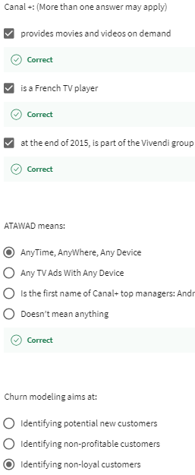

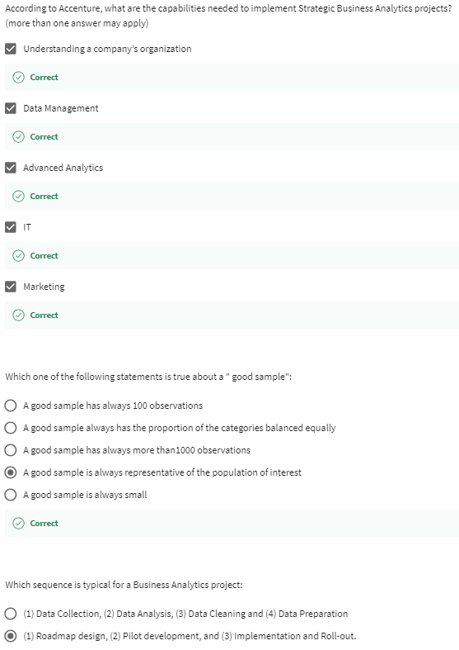

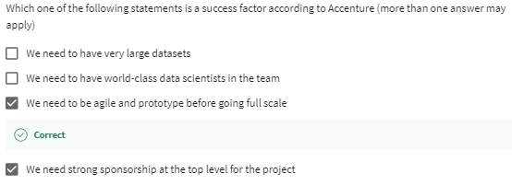

# Introduction and key digital trends in Financial Services

Hi, my name is Edwin Van Der Ouderaa.

I lead digital for financial service that Accenture and you know

my job is very exciting because I go around the world all the time,

and I can see what the banks are doing everywhere in terms of digital.

So, I talked to the CEOs of banks every day and we want to talk about one

of the cases that's really very interesting and that's

a very good example of what's interesting today.

Then, one of those banks is actually

a European bank which is doing a full digital transformation,

and at the heart of transformation is the setup of

a full analytics capability that is considered one of the very best in the world.

Why are we doing this? Well, in fact,

these banks they know that what we want as human beings is we want banking

to be like apps and we want them to react in real time where we are in the moment,

that I get responses in real time but just stopping and not using any paper.

In fact, people are not interested in banking at all.

People just want to do what they typically do in life.

They want to get on with things and maybe at

some point they'll decide that they want to go and buy a car,

maybe think about buying a washing machine,

or go and buy a house but up until now they have to

go to a branch and then fill in paper and then had to wait weeks to get an answer.

But now what we want is we want to be in the real time,

in the shop for example,

in the car dealership and with a few clicks in real time,

when we make a decision to buy the car for example,

we want to have the car loan also.

In fact, it's almost 24/7 that people are looking

for financial services because of the kind of things they do.

I don't think you'll be buying a car in the middle of the night,

but what we do see is that people think about the main decisions

in life not typically during

office hours because then they are quite busy doing other things.

But they are doing that for example at 10:00 o'clock at night.

Why? Because during the week they come home,

they're tired, they put the kids to bed,

they eat, and then finally after 10 o'clock,

they have a bit of time to relax and it's time to think about these things.

Or what we also see when we look at the usage

that people do when they query their mobile phones for

the banking app is that's it's going to be on a Saturday night

after dinner because it's time when we have time to think about these things.

Or on a Sunday morning,

most people think about buying a house on a Sunday morning.

They go for a stroll in the streets

and then they go and stand in front of a house and they say,

"Gee that's actually a great house wouldn't it be fantastic

if we could able to buy the house, if we could afford it?"

So, the bank needs to be there at that point in time and it needs to be able to respond.

It's then that I want to know whether or not I can buy that house.

I don't have to go back into the branch and during office hours get an appointment,

filling paperwork and then wait for weeks until I hear with

another that could buy the house because most likely it's already gone anyway.

So, it's all about creating

real time banks that are

based on analytics that are going to allow me to do all of these things.

# Analytics capability based on “People like you"

I will give you an example of a bank where we've installed

an analytics capability that allows them know how to predict what people want,

when they will want it,

and how they buy things.

That way, the bank can be ready to deliver

the services around those products in the most optimal way.

Clients in general are not interested in banking.

So, what they need is they want services that are going to

enable them to do the things that they really want to do,

like buy a car or buy a washing machine,

and maybe do savings,

but that's in function of something else they might want to buy and so on.

So, the way we're going to do this in terms of analytics is through what I call,

"People like You" techniques.

Now, for the technicians amongst us we can call it multivariate

analysis or cluster analysis and so on, microsegmentation.

But in fact, I think it's a slightly more easy to say it's people like you,

because it's like in Amazon.

People like you bought ABCD.

So, you might be interested and you think like, "How do they know that?"

Well, actually, it's because there are a lot of people that behave exactly like you.

If you take any European country with millions of people living in it,

what you will find is that it's not a good idea to do a big analytical model,

so monster model, that is going to look at

millions of customers at the same time and it's

going to number crunch for each individual,

what they may want, that is really doing it the hard way,

it doesn't function very well.

What you need to realize is that,

those millions of people,

they break down in groups,

groups of people that are like you,

people that behave the same way.

You may not know them personally but these people will under the same circumstances,

make the same choices,

find the same things important,

and therefore have the same behavior.

It is the finding of those groups that is the key to the analytics,

because that is going to allow us to understand your behavior,

understand the values of what you want,

what you find important,

the kind of things you will want to buy,

and therefore we can anticipate and the bank can offer the right credit,

or the right savings products,

the right investment products and so on.

So the people like you behave exactly the same way like you do.

They find the same things important in life,

they are at the same phase in their life,

so it's not just about demographics and it's not just about phases in life,

but it's because they have the same values and beliefs,

so they will make the same decisions as you

under the same circumstances in the same moments.

Once we can analyze that with the analytics,

we can really understand what the whole population does,

and we can predict what all the groups will do and therefore what you will do.

Therefore we can cater for the needs of the groups and get them

the right products and for you specifically at the right moment in time.

In one of those banks that we are talking about,

they had about 200 of these microsegments or groups of people like you,

that have the same behavior and

that kind of describes really population of the country because they have

a large market share and they have kind of people from all types so to speak,

and all walks of life in their client base.

But some banks they have like 100,

sometimes it's 300, it's always in that order of magnitude number of groups.

This is what we're going to use to describe what people will want.

For example, let's say a person walks into a BMW garage.

Now, it's probably not because they want to buy a washing machine,

it's most likely because they're interested in a car.

When the client has agreed for an

opted that the bank and with location services see where the person is,

then the bank can because of the analysis,

understand that that person is at a moment in

life we call it the typical zero moment of truth,

where the person is going to look at buying a car,

and so therefore because we have anticipated that,

we can start doing pre-scoring of

risk so that we can get everything ready for that customer.

Now, the pre-scoring and then the real-time credit score and that's going to

finalize that when we're in that dealership and he wants to buy the car,

can be done by using the same techniques.

So, as a way we're using for the marketing.

Why? It's because the bank will first to the classic credit scoring,

we're using Experian and other credit agencies and using all the standard models,

but then we're going to enrich it and combine it with what we call behavioral scoring.

Because the values and beliefs of these people that we can get out of

the analysis will not only tell us the kind of stuff they want to buy and when,

but it will also give indications about

their ethics with respect to things like finances,

are they responsible or not,

the way they look at loans,

are they going to pay them back or not,

so the whole attitude towards finances and loans can actually be derived from that.

It allows us to get much better risk scoring and in fact,

if we want to do real-time risk,

it can't be done with people in the back office doing stuff in real time,

has to be done automatically and we can do that now for let's say 90 percent or more of

the customers and situations that

the credit scoring can be done automatically because of all these enrichment.

At the same time we know that what we call the NPLs, the non-performing loans,

so the bad loans that are going to happen will be much less than in the past,

so the bank can with confidence write more loans,

write in an automatic fashion and still have the risk much better under control.

So therefore, what we are able to do is it's like a win-win,

the bank can at the same time keep it's risk under control,

but offer its products in real-time.

Even the customer from their perspective,

they see a bank that's relevant,

that gives them the solutions they need in real time,

in a situation in which they are in

and they can go and do whatever it is that they want to do,

like buying a house, or a car,

or a washing machine,

or maybe create a new investment products, et cetera.

# How to leverage “People like you” micro-segmentation - Example 1 – Increase campaign yield

When banks and insurance companies use this type of analytics,

they use them also not just to predict what people

want but to launch the right type of campaigns.

They could be pushed campaigns where they actively go out to the clients,

and they propose products or it could be pull campaigns,

where they kind of prepare an environment and they may do

some extra marketing, things about awareness,

so that the customers get ideas and then when they come to the bank,

and they say, "Hi, I might want to buy a washing machine,

and I might want a loan for that."

Then the bank is ready to give them the right proposals.

So, they basically create a sales funnel in which

the customers can walk in and then get the products.

When we do the classic bull campaigns,

we will also ensure that more traffic is generated,

that more customers will come in.

So, the bank will do for example, physical advertising,

it will do digital advertising,

it will do a whole number of communications.

So, they're not direct communications to sell them something,

but communications to give people ideas.

That way, they can create more traffic coming in,

and we know we can typically integrate more traffic with

three to five times more than usual in these types of campaigns.

Once the people are in and they are having the conversation added to push or pull,

what we have seen is that with this type of analytics,

you get an uplift in yield of sales between 300 and a thousand percent.

So, 3-10 times more sales for the same amount of effort of the campaign.

Because normal campaigning of banks,

is not very effective.

It has a yield of one to two percent.

That means that if you have 100 people that you have reached out to in a campaign,

only one to two people actually buy something,

and that's really not very good.

But this is typical how these things go.

A very good bank with a good marketing department,

champions in marketing, may be doing three percent or something.

But now when you do the real analytics

that understands the people of who wants to buy what, where, and when,

and who are the people that are relevant to contact and which ones are not,

you can actually increase the sales effectiveness and the yield of the campaigns,

from two percent to three times, 10 times more.

So, we can go to 10,

15 almost 20 percent sometimes

the people that are actually going to buy something. Why is that?

Is because we are now only going to contact

the people that we already predicted are going to need something,

because we know that from what we call the zero moment of truth,

that they are going through just like the people like them,

before them and we understood why they bought certain things like a car,

or a television, or something,

or they were excited to be interested in having a house.

So, these are the only people that we are going to contact.

We are going to give them an experience that is of value to them,

because we are going to do pre-scoring,

and we're going to give the messages that are laser precise on their specific situation.

So, from their perspective,

it's irrelevant communication from the bank,

and the product is ready,

and they can buy it and therefore they will more easily decide to buy it,

and in a sense everybody wins,

because the customer sees a bank that is very responsive,

tailored, and the bank itself has much less sales efforts to do.

So, it costs much less, and at the same time,

it can deliver the right products for its clients.

# How to leverage “People like you” micro-segmentation - Example 2 – Optimize pricing

One of the other things that you can do with

the analytics of the people like you is to look at price elasticity.

So, what's the right price for

a certain banking or insurance products for those groups of clients?

Again, what we will do is we will look at the people like you.

Why? Because the people that are like

you they have the same ethics and values and beliefs.

They find the same things important in life.

They will have the same outlook in life.

So, there will be, as when we analyze it,

be the same factors that influence their pricing decisions.

So, how they look at the price.

Do they look at the optical numbers?

Do they make a calculation in their head of some sort?

Are they influenced by other aspects of the price?

So, these things are analyzed and because of that,

we can desensitize what we call the price

elasticity for that group and for that individual.

So, desensitize means that we can change the pricing in a way which of course is

advantage for the bank or the insurance company and

that the customer still feels they are getting good value.

A good example of that in

a low interest rate environment that we are now in the Eurozone deposits.

What do you get for deposits?

10, 20, 30 basis points, okay,

not even percentages but basis points, which is not much.

In that kind of environment,

we can probably have a differential of five to 10 basis points which

is 15 to 20 percent of the total amount of interest that we could

desensitize or differentiate by looking at the other factors that determine why

the customer is making the decision to have deposits in

general and deposits in this specific product and at that specific bank.

Okay. There are plenty of other aspects that they also find very important.

Like for example, the experience of of making the saving.

An example that I had recently is from all the ladies that bring in cash every

week on a Saturday because that's what's

leftover of the money that they spend during the week on their groceries.

So, they're constantly thinking about if I save a bit of money here and there,

the reward for me mentally on Saturday is

that I have like €20 I could put on savings account.

And we can see that in there in the pattern of how they save.

Then there are other people that safe each time with

a pocket of like €500 and they do that in one go.

So, they kind of save that up themselves and then do it in one day pockets.

So, there is a very big difference in how people look at the experience of saving.

Similarly, in loans it's the same things.

We find that we can,

in the current environment in the Eurozone for examples,

I'm not talking about Latin America or one of

those countries with very high or regions with very high interest rates,

but in Eurozone 20 to 50 basis points on a loan,

and this would be a car loan for example or a consumer loan,

is a typical amount that we can actually increase the price and the bank

would still sell as many loans to their customers.

Why? Because we have differentiated

products and some customers are very very price sensitive.

So, for them there may be loan products that are

very very competitive in terms of price but for other products,

it's other, what we call bells and whistles,

that are very important in those products.

So, we will emphasize those and give products

that people really like but they might be a bit more expensive.

Okay. The same is true in insurance.

What we have found is that when you are in a market with

fully commodity insurance products like

very standard run-of-the-mill car insurance for simple cars,

very average so little cars,

what we find is that the price differential that you can do

in this fully commoditized market would be about five percent.

If you want to do more,

if you want them to pay like 10 percent more for the premium,

you need to offer them something extra.

You can't just do it with good marketing and good branding.

You need to give them bells and whistles.

So, we will look at what the values are that these people

see in the experience of having a car insurance on

their car and we will create those bells and whistles that are

put in the products so we have differentiated products for those groups of customers.

They can be priced a little bit higher because they are getting that extra value.

Okay. And that you can do to 10 percent.

I have seen a little bit more than that but not much more

because if I would try to stretch it to 15 or 20 percent,

then what do we see is that there is a disconnect that people will say, "Yeah yeah.

Okay. This product looks great.

It's got all that extra stuff.

However, it's really expensive.

So, I'm not going to take it anyway.

It would have been nice but I'm not doing it."

Okay. So, then I have a disconnect there.

What we call suspend of disbelief in marketing terms.

So in that case,

what we need to do is we need to come up with

fully repackaged and rebranded products that

are positioned in a very different way

if you want to capture that extra price elasticity.

# Digital transformation and wrap-up

One bank in Europe, by doing

all these real-time analytics that we have been talking about,

has been able to start shifting sales from the physical channels to the digital channels.

Because in the end,

people want to buy through their mobile phone. Why the mobile phone?

Because that's the main device that they use for querying

about information and when they're in the situation that they're in,

whenever they want to buy the car,

or the house, or the washing machine,

or whatever it is that they are actually thinking about the things that they want to do,

and what this bank has been doing very

successfully is by applying the analytics is moving

the sales to digital to 10 percent,10 percent to 20 percent to 30 percent,

and now trying to get to 40 percent,

and so, the model starts to pivot.

So, this is a good example and there are plenty of banks,

in fact if you're going to look at when

banks talking their vista communications about their digital transformations,

they are talking about how they are shifting the sales

more and more to digital so onto these devices.

Okay. Then, because of that,

they can then start reducing the cost base of the physical channels, okay.

So, at the same time they can offer real-time services that are relevant for

their clients and it becomes easier and cheaper for the bank to service them.

Now, what we have seen is that the banks that are doing this really well,

because they are getting a cost advantage and they are giving superior service,

they are able to make a strategic choice,

which is to give part of that cost-saving back to the customers in competitive rates.

So, we've seen that we can do analytics to

actually increase the margins on the one hand in price,

but on the other you can use the same mechanism to then give in

fact very competitive prices when it's relevant to do so.

Because if you're going to give them a low price when it's not required,

then you're just giving away margin for nothing.

So, this is really the power of the good digital banks, what they're doing.

So, they are moving first up to 50 percent of sales digitally to these devices,

then the model shifts to digital first and then the sales can go up even to 50 percent,

60 percent, 70 percent of sales done digitally.

As that is happening,

the function of the branch changes,

and the function of the call center changes,

because we're taking away all the transactions,

we're taking away all the papers and everything is becoming about just with a

few taps getting all the services done and the sales done through the mobile phone.

So, the function of the sales force shifts from being there to sell,

to actually doing advice and relationship.

So, this is the moment when digital sales becomes 50 percent and more,

where banks can start reducing the branches and optimize the structure of the branches,

their function, where they are located, okay?

At the same time, what we are seeing is people go less and less to the branches.

So all the banks are telling me that what we call the footfall,

the amount of people in the branches is going down drastically, okay?

So, at the same time because they still need them for sales,

they're obliged to keep all these branches that are kind of

empty and at the same time they would need to reduce the costs.

So, the key is really to move the sales to the digital devices and

then to reduce the amount of branches afterwards.

But it's very important not to take away all of the branches,

and actually some banks really want to keep a lot of branches,

but then the branch will be cheaper,

there'll be less people in it,

and these will be relationship branches, why?

Because people, even the millennials,

still want to have personal advice,

that is valued very much by people.

So, they just want to hassle to go away so they could do everything in real-time,

but at the same time they want to be able to talk to people.

So, we should never forget them.

But the same analytics that we have been using to predict what

people want and to provide them in real-time with the credit score,

loans and whatever, we can use that same

analytics to also support the relationship managers.

So, when I am going to call my relationship manager,

I am signaling that I want to talk to him and then

he gets in a few seconds an overview of me and people like

me and analyze my situation and it will suggest to

him what the best way for him is to talk to me.

So, they chat with me like in Snapchat or something,

should he do telephone conversation,

should he do a FaceTime with me,

should he meet me at Starbucks,

or maybe should he meet me in a more closed environment at the bank,

where we can talk in a more discreet way, okay?

All of that will be determined so that there is the optimal type of conversation.

He will also get all the information on what my current context is?

What the likely questions are that I am going to ask?

And what the best answers to all of that would be?

So, that he can have

a very productive conversation and he can personalize that conversation.

So from my perspective,

I will have the impression that this bank is very responsive to me,

and that they are giving me a personal treatment and that they understand about me,

and that they are available,

and that they are available whenever I need them to have a conversation.

All of this type of analytics that we've been talking about,

we believe are going to be a commodity in

two to three years something like that from now,

and they're going to be a must-have.

Banks that will not be using this type of analytics to

really understand to behave to the groups of the customers and of the individuals,

and then be able to use it in real-time for

personalized interactions and for personalized products to give to our customers,

they will not be able to follow.

They are basically running blind,

because think about it the other way around.

If they are not using that,

it's really like a blind man.

How would they know what the customers want?

There's no surprise that a lot of banks have

such bad yield in their marketing and that they are

having difficulty with their market share and what we will see that the banks that are

not adopting these new technologies will lose market share very quickly.

In fact, we've already seen this happen in several markets.

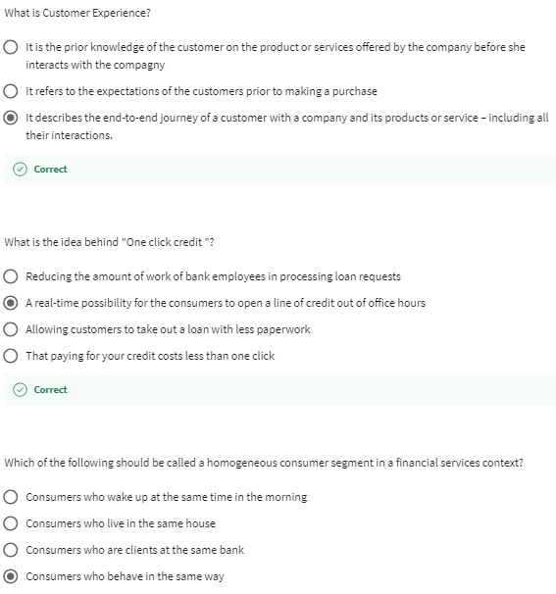

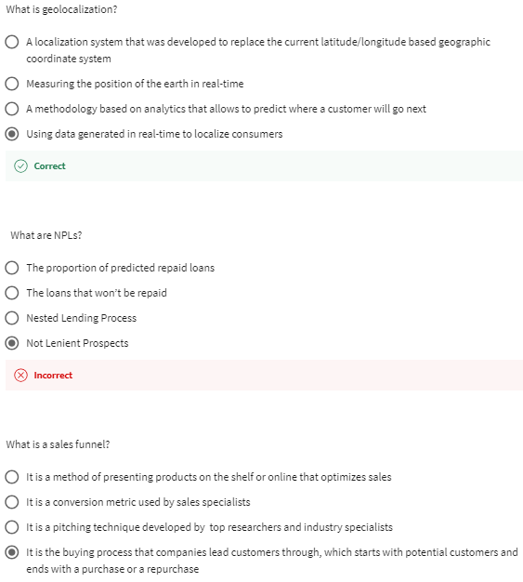

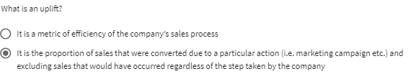

# Healthcare analytics: a conceptual framework - Nicolas Glady

In a previous video, we started analyzing the Internet of Things,

and all the connections between humans, machines.

I said that one of the most interesting field of applications was probably health.

So, now let's discuss this question.

As I said in the introduction of this MOOC, big data is mostly characterized

by decentralized and real-time user-generated data.

But analytics in general was around for many years before the big data revolution.

And there are classic applications and analytics for

healthcare, which do not require the collection of user-generated data.

Play video starting at ::48 and follow transcript0:48

So, let's analyze those applications along two dimensions.

The type of data and

the level of aggregation, what we call the granularity of the data.

Play video starting at ::58 and follow transcript0:58

And let's first start with the traditional applications of analytics for healthcare.

As a matter of fact, even before our big data times, data and

statistics were largely used for healthcare at two levels.

At a collective level first.

Since states and

organizations can collect data about a population of a certain region or

with a certain social demographic in order to monitor our public health.

Knowing the proportion of a certain disease for

a certain part of the population is useful to mitigate health risks.

Play video starting at :1:31 and follow transcript1:31

And even before our smartwatches, pedometers,

and other digital devices, at the individual level we

used to collect data to monitor certain biometrics about us.

Weight, bodyfat, heart rate, blood pressure,

etc, in order to improve our life expectancy, for instance.

Moreover, one doesn't need advanced

state of the art digital devices to collect such data.

Play video starting at :1:57 and follow transcript1:57

But then, what can we do with the data that we couldn't do before?

First, we can certainly do the same conditional data collection as before, but

faster and more efficiently.

That's certainly something that we shouldn't disregard.

But you can also use data in other ways that were not possible in the past.

At the collective level first.

Thanks to decentralized and real life user generated data, we can for

instance, monitor the flow of population in a certain region.

And subsequently, anticipate the development of certain diseases.

There are interesting cases where thanks to the very well known search engines,

we can forecast the development of the flu over time.

Play video starting at :2:40 and follow transcript2:40

During the Ebola crisis, thanks to the of smartphones,

it was possible to monitor and anticipate geographical epidemic developments.

Play video starting at :2:51 and follow transcript2:51

This is certainly useful in terms of public health and safety.

Then, at the individual level, even if the applications are still currently

just emerging, we can anticipate amazing developments in this field.

Some pharma companies are developing devices

with multiple biometric [INAUDIBLE].

And with the generalization of those solutions for mass markets,

it's just a matter of time before very advanced devices become available for

consumers that monitor the risk of rare diseases or

even more common ones like diabetes for instance.

Play video starting at :3:26 and follow transcript3:26

And actually, some smartwatches are even very close to providing such

advanced metrics very soon.

Who knows, one day, you may have at home or even on the fly,

the same level of monitoring as what you would have in a hospital.

Play video starting at :3:41 and follow transcript3:41

You could benefit from a closed hospital level monitoring if you're at risk,

while living a better life closer to your family.

It would improve the general quality of the public health while

also improving the general quality of your life.

Decentralization and proximity to the consumer is once again a benefit for

everyone.

# Introduction and key challenges - Paul Pierotti

Hello, my name is Paul Pierotti.

I'm a managing director at Accenture Digital, and

I'm working within healthcare analytics.

I'm here to talk to you about how analytics can transform the way we deliver

our health services and deliver more efficient and more effective services.

So let's start with a little bit of context.

Play video starting at ::31 and follow transcript0:31

It's important to think of some of the key challenges that we're seeing

around the current health system.

Firstly, population.

Play video starting at ::39 and follow transcript0:39

We're seeing a significant rise in our aging population,

agreeing over populations as people get older.

And, what you see then is that, your seeing more people with.

With at least one, often many chronic diseases, and

that has an implication for our health system.

It's wonderful that people are living longer.

At the same time we need to make sure that we

adjust our services accordingly to make sure that we have an efficient and

effective health care to deliver on that demand.

And, that's the second point here on care delivery.

You hear this a lot of places whereas historically it was seen that

the hospital was the best place to give care.

Very much that's changed and

the realization that the more quickly you can get involved with a patient

before they become ill, before they end up in hospital is in everyone's interest.

Also new technology there has allowed us to do some amazing things that we couldn't

do before.

And you really see the Internet of things and many of those senses and

areas coming into your home as you effectively have a home diagnostics

working with you 24-7 when you're in your own house.

Third, partly is economics, as I've mentioned before.

The reality is for many Western economies,

we can no longer afford the way we deliver our health systems.

And we need to make that push from the hospitals into the community and

actually push more for self care where individuals are actually taking more

responsibility for their own health.

Play video starting at :2:6 and follow transcript2:06

So I'm going to talk to you today about some of the ways that analytics can help

deliver and address some of those challenges.

# Correlation between life expectancy and health spending - Paul Pierotti

Before I go into the detail, I want to show you my favorite graph ever.

And as a statistician, I love lots of graphs but

this is the one that makes me smile the most.

What this does, is it looks at the spent per country in healthcare and

the comparison of that with a number of years that people are unexpected to live.

Play video starting at ::32 and follow transcript0:32

Those two things I want to highlight in this draft.

Firstly, absolutely there is a relationship between spending and

life expectancy.

This is probably as you would expect.

The more a health system commits to its health budget,

the better outcomes we see for our patients.

However, however, however,

I also want you to notice the one massive outlier on that graph.

And that's the United States.

Play video starting at :1:2 and follow transcript1:02

Now how I interpret that, is the United States is delivering worse

health outcomes than many European countries for more spent.

Now there are some wonderful things with the American health system, so please,

I did not mean to degrade it.

But what I want you to do is realize that the way we structure our health system and

where we put that investment can have a significant impact on

the outcomes that we get as citizens.

And that's something that hopefully when you think about it is obvious

from healthcare.

That healthcare is an economy where you have to place investments accordingly.

And something that's really important to keep in your mind just as we talk forward.

# Presentation of 5 Health Analytics use cases - Paul Pierotti

So moving forward, I want you to just reference the five ideas that we often see

analytics can help healthcare.

And I will do a deeper dive into one or two of them.

First, with population health planning,

understanding as we've said that ongoing change in evolution and demand and

the massive impact it's having in our capacity requirements.

And analytics has a role to play.

First from epidemiology, understanding how that demand is changing.

And then also as we reconfigure our health services to make sure we have the right

number of nurses, doctors, GPs, community pharmacists, beds, whatever across them.

Assess them both short term and long term to meet that demand.

Play video starting at ::49 and follow transcript0:49

Secondary is provider cost containment.

The reality is there is huge variation.

And a health kit is delivered.

I'm currently standing in Ireland at the moment.

One of the STEM studies here in Ireland showed that one hospital in Ireland

delivers 100% of cataracts as surgery.

Another hospital not that far down the road delivers 100 as inpatient.

So that is one hospital gets you in overnight, the other hospital doesn't.

That's a decisions that each of those hospitals have made.

The impact on the patient, from a quality perspective, is minimal.

And I think it's important to understand that there are efficiency differences and

service delivery differences that can make a huge impact on the overall cost.

Top areas for non-compliance.

The reality is that it's up to 7% of spent.

And health care is due to fraud and non-compliance.

And analytics can play a critical role in helping better identify and

mitigate and address those issues.

I'll come back to that in a little bit more detail in a sec.

And then also clinical delivery transformation.

We are now embedding the health analytics in the actual patient process and

patient pathway to fundamentally change health outcomes.

A great example of that's what we've been doing in the US with the hospital

where we identify for heart patients a 300% variation, and

the readmission risk for particular patients.

And think about that from if you're a healthcare planner.

If you know that one patient has

a 300% higher chance of having complications of having to be readmitted,

what additional services can you wrap around that individual?

And then last area is care management.

Almost extending that to a specific area.

And very much,

hopefully, a common theme that you hear me talking about throughout this,

this coinset that we as a health system have failed you if you end up in hospital.

And how can we use productive healthcare analytics to catch those people before

their chronitity becomes too severe?

# Focus on Care Management for patients with chronic diseases - Paul Pierotti

In particular and the top 5% of patients are responsible for

a huge percentage of the total cost related to healthcare.

To give you a calculation, they typically say the top 20% is 60% of the total cost

and that's been shown across a variety of Western countries to be broadly the same.

So it's a relatively small number of patients

that are actually having a huge contribution to our health costs,

we need to see that as because we were failing them as well.

Play video starting at ::38 and follow transcript0:38

Again, here in Dublin, there was analysis done previously with the hospital

population in Dublin a number of years ago.

Where it showed that at any one point, 70% of the hospital

population are people with at least one chronic disease.

35%, half of that again have got at least two chronic diseases.

So what can we do about that?

Play video starting at :1:6 and follow transcript1:06

So, one of the things really that comes into play here is this concept of

productive analytics.

So can you use predictive analytics to identify

patients who are likely to have a chronic outcome,

an acute outcome before it actually happens?

And what you can see here is a graph that's been shown across a number

of areas and it's quite common.

What you see is there's an increased escalation of an acuity of these

patients Patients get sicker as they start to lose control of the chronic

condition to no fault of their own necessarily and been able to identify

those patients on that path towards ending up at hospital and predicting that

enables a significant improvement in actually their quality of life.

And also,

a significant reduction in the number of those patients ending up in hospital.

Play video starting at :2:2 and follow transcript2:02

What you can also see predictive analytics

doing is being much more targeted, as well.

So for example, some work we've done before is focused again on heart patients.

Can we better identify the patients likely to have and a heart attack?

Is there something we can do in that space to

be able to use the data we have on these people and

to be able to predict before it happens and then intervene accordingly?

I think the other thing that's important in this space is to think about

the industrialization of this.

In many ways, what we're talking about is a campaign, is a wellness campaign.

And other industries like tell calls and banking have got brilliant at iterating,

improving the interventions they have for

their marketing campaigns to have a better outcome for their customers.

They're famous about selling products.

Healthcare affiliates is more complex, but the principle applies and

we need to be thinking about as we start to better segment and predict for

these customer groups, for these patient groups.

What's the best medical intervention we can do

to help them not have that acute episode and not end up in hospital?

We have worked with a breadth of clients to show that you can embed

predictive analytics into the healthcare system and

identify patients at risk and intervene in a cost effective way

to improve the health outcome and reduce the costs.

And with three health region of the Valencia area in Spain, we walked with

them to protect patients that were likely to end up in hospital for a long period.

Not surprisingly, many of those patients were the ones that the other single or

couple of touches with before over the last few years,

but with this restratification allowed them to do was absolutely target

those groups of patients at the highest risk.

Working with some excellent commissions in Le Fevre, we were able to

develop the best health interventions with those that were there and

actions by Le Feyre themselves and what that showed was that it

actually reduced the hospital demand for that group by 20%.

Now that's incredible, that's huge and it's absolutely wonderful and

I think the thing we need to have in our mind is this is something

that we need to start to embed as standard across all of our health systems.

# Wrap up - Paul Pierotti

I think the last point for me to say is, we're only at the start of this journey.

In particular, as we start to get more and more health information,

the ability, be that through the devices that you have in your house.

Be it the FitBit that you wear on your wrist.

And we need to find a way to incorporate that to have better health assessments and

health outcome decisions.

Though I fully understand that there are risks related to that, and

we need a conversation to make sure that people are comfortable with their

governments around their health data.

If people don't trust how the data is used this will never work.

At the same time, we're in a position just now,

where people seem to be more willing to give up their bodies after life for

medical research over their actual health data.

That seems wrong, it seems a bit daft.

So I think the thing to see is we really need to focus on proving the value

of this.

And ensuring that the right governance is in place,

that we can deliver these improvements in health care.

Thank you for listening to me today, and I really do appreciate your time.

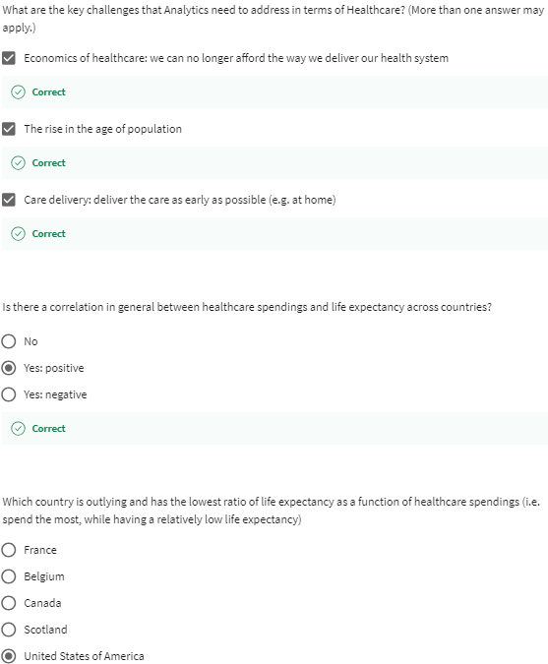

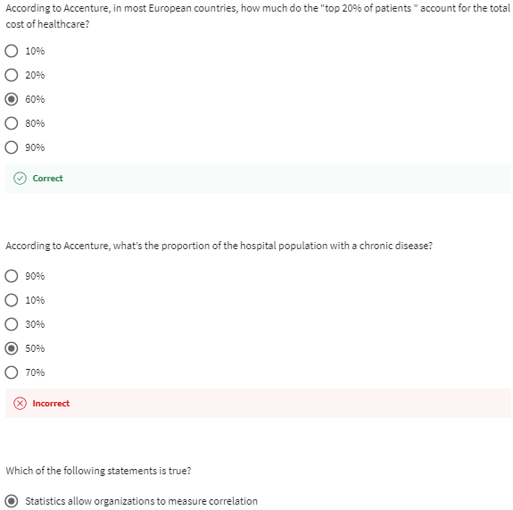

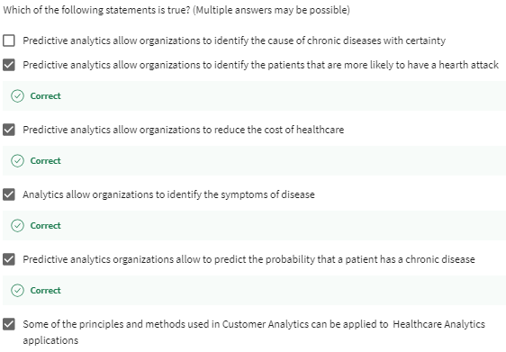

# Advanced Analytics in the Pharmaceutical industry - Xavier Cimino

Hello I am Xavier Cimino managing director from the Paris office in charge

of the analytics practice in the life science industry for Europe.

As such I was involved in a very interesting project that we run for

our license company two years ago.

This project was about how to be able to use the data and the analytics in order

to be able to better serve patient needs, and also to better understand

the customer needs in the context of a new health care ecosystem.

Play video starting at ::41 and follow transcript0:41

The company decided that the data was an enterprise asset, and

wanted to put into place an Open Innovation Data Lab.

As such, they decided to move forward with Accenture

as a key partner to be able to develop a Data Innovation Lab.

So the solution that we put into place was based on two-pillar.

The first pillar was a strategic council.

The strategic council was given to the pharmaceutical company,

one, the vision and the road map to develop analytics of the company.

Two, the ability to tap into some senior leadership and some external

thought leaders, to be able to come up with some new business questions and

topics that would interest the pharmaceutical company.

The second pillar was based on what we have called Sprint.

A Sprint was there to actually answer a specific business question.

It is a time box 50 Mondays exercise that starts with first

assessing what are the internal and external data available.

Second, use the statistics and

the advanced analytics technique to be able to come up with results.

Third, use the data discovery and

data visualization tool to present the results to the business.

The objective of the Sprint is to actually assess the outcome and

then identify whether or not there is a need and

a value to actually industrialize the way we are using these data.

Let's take one concrete examples in the domain of sales and marketing.

The objective of the Sprint was to be able to measure the marketing effectiveness.

The way we did that was first, to collect the data in order to be able to

segment doctors into categories, looking at what is the potential of each doctor.

Play video starting at :2:37 and follow transcript2:37

Second, to measure the promotional effectiveness looking at

the investments that are made per category of doctor, and

looking at what is the impact of those investments over time.

Then third, create alternative allocation scenario to be able to

play with the different levers that were addressable on the market.

Play video starting at :3:2 and follow transcript3:02

By doing so, you are able to come up with a new way of

using the money more wisely in the context.

So second concrete example of Sprint is the Sprint around Net Promoter Score.

So Net Promoter Score is a key technique to be able to measure

satisfaction from the doctor in the context of customer relationship.

In order to do so, we do three things.

First of all, we start crawling the data that is available from the doctor.

So, we take all the feedback from the doctor in a text format.

Then, we apply text mining techniques in order to

cluster all of those feedbacks into some specific categories.

Once we have those categories, we then serve,

starting to analyze the relationship between those old causes, and

the fact that the doctors are more or less satisfied by the pharmaceutical company.

Play video starting at :4:4 and follow transcript4:04

By doing and applying this to a large scale of data, all around the world,

the pharmaceutical company is actually able to monitor all

the time the level of satisfaction of their customer, and therefore increase and

improve their customer service.

So the results of this data innovation lab is twofold.

Play video starting at :4:24 and follow transcript4:24

First of all, it has some

internal resonance.

The way we measure success of this Data Innovation Lab is to look at

how many thick orders from the business are submitting new

business questions to the Data Innovation Lab.

The more questions we have the more successful we demonstrate this program is.

The second way of measuring it is the external knowledge of this program.

And in this case, the pharmaceutical company actually won a specific

award externally with an IT magazine that actually declared that this

program was a specific project of the year two years ago.

Then why is it successful.

Two reasons.

First, spending little money to be able to demonstrate a lot of value in short term.

Play video starting at :5:21 and follow transcript5:21

Second by making some noise around how the data can be used.

And now you can bridge some knowledge gap by using data that comes from either

internal cross-functional data or external publicly available data,

that are there and not always used by the company.

Play video starting at :5:41 and follow transcript5:41

In conclusion there are five key lessons learned to be able to put in

place Data Innovation Lab.

The first one is that you need to be focused on the business

questions that actually matters for your company.

Play video starting at :5:58 and follow transcript5:58

It is ultimately the most important thing.

And in the case of this pharmaceutical company,

it was really about understanding customers and patient needs.

Play video starting at :6:9 and follow transcript6:09

The second key topic is actually to be able

to consider data as an enterprise asset.

Data is not the ownership of one specific function, data is the oil for tomorrow.

So data needs to be considere as an enterprise asset and it be,

it has to be a clear mandate from the top management to do so.

The third lessons learned is to be agile.

Be agile means that you need to be able to come up with

a way to use data which is flexible enough to provide value,

whatever the data set you have or whatever the techniques you need to use.

The first lessons learned is around, Make noise.

You need to share, you need to show the results of the data.

You need to make it accessible to the business by using the right tools and

by having the right story telling around the results of your data.

And then the last lessons learned, which is critical as well,

is that you need to make sure that the IT is actually a key enabler to

be able to scale at the right level.

Meaning that you don't want it to stay at a lab level, but you want to make sure

that it's then industrialized, so that everybody can use it and can replicate it.

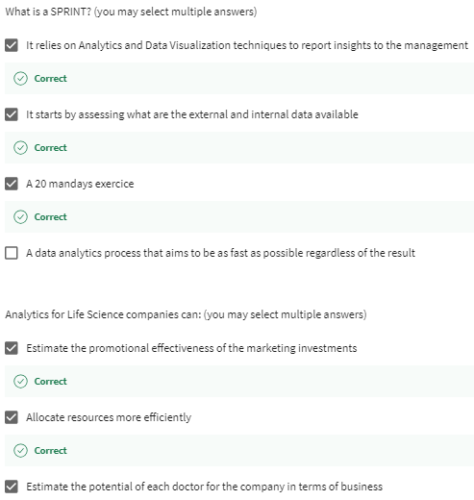

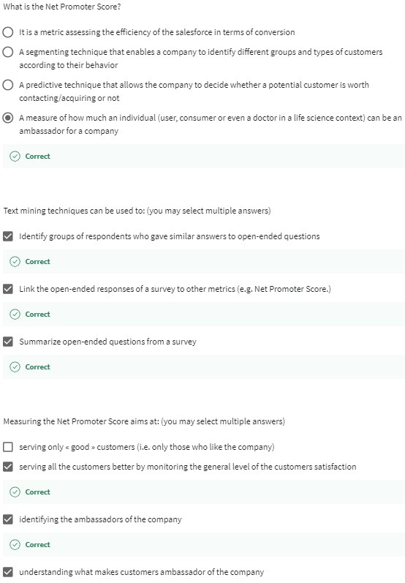

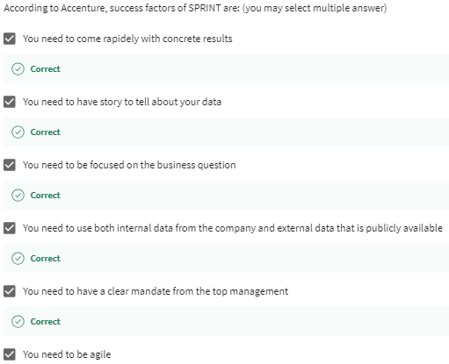

# How to create value from data? - Fabrice Marque

Accenture conducted a number of research on analytics issues with MIT in 2014.

The research proposed was to understand the correlation between ROI

performance and analytics capabilities.

Play video starting at ::23 and follow transcript0:23

Here is what was discovered.

Although the adoption of analytics has tripled in the last three years,

the average ROI still lags behind expectations,

only one out of five companies is very satisfied.

We call these companies the High Performers.

They are able to capture the value of analytics because they adapt

the organization and follow a value-driven approach.

But how to follow a value-driven approach

to show the extent to which the original objective has been fulfilled?

Look at this strategy set, the value creation tree.

The value creation tree uses a tree structure to document the relationship

between client objectives, value drivers, and team metrics.

Based on a deep understanding of the client and its industry, we can

identify value creation opportunities, vet and select projects to execute,

while ensuring these opportunities are aligned to the strategic priorities and

value drivers that will deliver expected client outcomes.

Play video starting at :1:26 and follow transcript1:26

What is a value driver?

Value drivers are the operating factors

with the greatest influence on strategic execution and value creation.

They are either financial or strategic.

How to create a client value tree?

Play video starting at :1:41 and follow transcript1:41

First, review the client context and determine key client priorities.

The second phase is about discussing and documenting key objectives.

Then it's time to identify key value drivers by using client value statement.

Finally, document and agree on value metrics that support each value driver.

To conclude, the value creation tree identifies

key operating factors with the greatest influence on strategic execution,

inverse is the key assist for value driven approach.

[BLANK AUDIO]

# Wrap up - Mickael Svilar

Hello, my name is Michael Svilar.

I lead Accenture's Data Science Group globally.

These case studies have covered various industries

in different business challenges.

Play video starting at ::18 and follow transcript0:18

Among other cases, you learned how a fuel company can optimize its prices and

promotions, how a hospital can anticipate treatments for its patients with

chronic diseases to reduce to overall length of the inpatient stays.

Our TV company can help viewers decide on what to watch to reduce churn.

Our pharmaceutical company created a data lab

to better capture value throughout its business.

All of that was made possible by the use of analytics.

We hope those case studies have helped you better understand

how the companies leverage business analytics to solve their challenges.

Now it's your turn.

With the capstone project you will learn how to create value from a data set.

Leverage what you've learned through the case studies to make your case

even better.

# Data exploration is an iterative process - Nicolas Glady

I'd like to spend some time with you discussing how you can approach a data

exploration project.

This is very important, because very often you will have a new dataset that you

don't know and that you'd like to explore.

You may have a business question, or

some idea about what could be relevant to doing this context.

But actually, you don't really know what you could do with this specific dataset.

And so the question is, should I first have an hypothesis to test,

or should I first look at the data?

Actually, the answer is both.

It will be an interactive process, because you don't really know what's in the data.

And if you don't really know what you're looking for, it will be

very difficult to understand what's the type of data you need to collect.

So it's normal to go back and

forth between what we call business understanding or business qualification,

what's really the question you want to address, and data preparation.

Selecting the right data.

So let's take a very concrete example.

Let's imagine that you want to identify the churners in your company.

So the customers that are leaving for the competition.

You have different datasets, like the transactional information.

This type of dataset, by the way, is usually the most useful ones.

And then you have the contextual data and the social demographics.

But you don't really know what's relevant.

So what you would typically do is make some very basic summarized statistics on

the different datasets you have.

And so you will make a table,

for instance, of the frequency of churners by category.

Or you may also do boxplots or histograms for specific variables.

So you just want to see what's the structure you could see in the data.

And then after awhile once you get familiarized with the dataset,

you will see what you have in front of you.

And you can start testing some ideas you could have.

Play video starting at :1:57 and follow transcript1:57

I'm expecting that the certain variable is correlated with another one.

Let's do it.

Let's do this correlation analysis as we explained in the previous video.

I am imagining that there is a relationship between several factors and

my variable of interest.

Here in this context would be churn.

I can for instance do aggression, and test if I see significant differences.

And that two things that could be interesting in this context.

It could be first that you find a significant effect that you didn't expect.

Which is always very interesting, but that needs to be investigated.

Or actually exactly the opposite.

It could be that you expect an effect, and

you don't see it when you're looking at your dataset.

And in the two cases, it's really interesting to investigate.

And so it means that you will requalify the question you have and try to

understand why you don't see the effect you're expecting to see, or you see it.

You are coming back and forth between question, business question qualification,

and data analysis.

But it's not always the same data you analyze and

the same business question you qualify.

So you start with the general question,

like what's the proportion of churner in my dataset?

Or what are the effects leading to churn?

You do your aggression, you do your analysis.

And you realize that you have an effect that is surprising or

effect that is very strong.

What you will do then is that you will focus on that specific variable.

And you will try to understand what makes this relationship special?

So you will make your analysis specific to this variable.

It may be that you want to do aggression,

it may be that you will test some histogram or some visualization.

But it will allow you to investigate.

And you will start collecting a bunch of analyses, tables, plots.

So after a while, you may want to

summarize the different presents you produced in something that makes sense.

And that's where the story line is so important.

You may remember that in a previous video,

I explained how to make a story line from a presentation.

That's the moment where you can do it,

because you've produced all those different statistics.

At first, it didn't look like it was related whatsoever.

But when you look at it,

you realize that indeed, I see several patterns that are related to each other.

And so maybe we can make a story out of it.

We can first start by the problem, and then develop why the problem is important.

And what do we see that is related to this problem in this fashion?

And so one by one you develop the different analyses you need to produce.

# Analytics exploration - Oonagh O’Shea & Noelle Doody

Hi.

My name is Oonagh O'Shea and I'm a management scientist in

the Accenture Analytics Innovation Centre in Dublin.

>> Hi. My name is Noelle Doody and

I'm also a management scientist in the Dublin Analytics Center.

Today we're here to talk to you about analytics exploration.

Analytics exploration is a starting point of using data to generate business

insight.

The cornerstone of analytics exploration is starting with a question.

Play video starting at ::37 and follow transcript0:37

So why do you need this business insight?

What problem are you trying to solve?

Play video starting at ::42 and follow transcript0:42

For example, a retailer may want to solve a variety of problems,

from optimizing a supply chain to creating a successful marketing campaign.

To address these challenges, the retailer may need insights such as who their

customers are, what they are buying, and where and when they are buying it.

So once we are clear what problem we are trying to solve, and

before we even touch any data, we need to talk to the business to understand how

the question at hand is addressed today.

Then, we speak to our data experts to understand what data is available,

and how does this help you solve the problem.

Now it's time to get hands-on with the data.

Play video starting at :1:24 and follow transcript1:24

Start to understand the data at a high level.

Summary statistics such as sums, accounts, mean, median,

standard deviation and range are all very helpful to do this.

The next step is to review this information, and

to insure it aligns with your expectations of the data based on your

previous discussions with the business.

Play video starting at :1:46 and follow transcript1:46

To continue our example of the retailer, at this point, we would confirm that

things like the total number of customers, the total number of transactions and

the total value of sales are all in line with the business expectations.

This is a great time to identify any data cleansing or data quality improvements

that you may need to make in order to prepare for the next steps.

>> Once you have that high level understanding of the data you can now dig

a little deeper.

In analytics exploration, it is very useful to visualize your data.

For numeric data, tools such as box plots, histograms, and

time series plots will give great insight.

Play video starting at :2:29 and follow transcript2:29

You might use a histogram to understand the typical age profile of your customers.

Play video starting at :2:35 and follow transcript2:35

You may use a box plot to identify observations which are unusual compared

to the vast majority of your population, such as high worth transactions.

Time series plots will allow you to visualize what is happening over time for

your population.

Are people changing their spending patterns, or

are there seasonal spending patterns in the data?

Use bar charts, frequently, and

tabular analysis to gain insight from categorical data.

For example, where in the world are you customers typically from?

Are certain stores more popular than others?

Play video starting at :3:17 and follow transcript3:17

Binning is a useful strategy for gaining further insight.

This involves categorizing very granular data into meaningful, higher level groups.

You may want to find out how rural and urban based stores compare.

And we would do this by grouping the stores And analysing s this higher level.

Up to now, you have been looking at variables one by one, or univarically.

We can get more insight by looking at variables in

combination to understand more complex patterns.

Is there a relationship between the age of a customer and the amount they spend?

What is the nature of this relationship?

Using correlation analysis, you can answer questions such as these.

You may also have theories.

For example, the customers in the US spend more on average than customers in Europe.

Hypothesis testing allows you to test such theories to a degree of confidence.

Play video starting at :4:25 and follow transcript4:25

With Analytics Exploration techniques such as those mentioned,

you are building a solid knowledge of your data and preparing for

the next phase advanced analytics where you not only understand the past but

use this information to predict the future and maybe even changes.

# Wrap up & Capstone guidelines - Nicolas Glady

With this MOOC, Case Studies in Business Analytics with Accenture,

you've been exposed to examples of how to apply analytics to values business issues.

Thanks to the tools we've provided in the first two MOOCs,

you should now have everything you need to start the capstone project.

Before starting this capstone project,

I would recommend you watch some of the videos from our specialization again.

First the video where Mark explains how to create value from data.

And also the videos where we present how to approach a business analytics project.

Play video starting at ::48 and follow transcript0:48

Remember the data visualization is very important when exploring a new data set

and that this exploration should always be driven by business questions.

Finally, remember that it's an interactive process and that it's normal to come

back and forth between data exploration and the business question qualification.

You'll probably change the way you present the issue you want to address

as you start to better understand data you have in front of you.

Second, you should also return to what the last module of the MOOC,

Foundations of Business Analytics,

again on how to present the result of your analysis in a business oriented way.

Play video starting at :1:29 and follow transcript1:29

Data visualization is here again very important, but

to emphasize the message you want to transmit,

not only to explore your dataset, it needs to be well presented.

In addition, focus on what matters,

what really addresses your business issue, what is actionable and relevant.

Do not dwell too much on the technical matters you've been using.

It needs to be clearly explained because it will make your story more believable

but shouldn't constitute the core of your presentation

as it is just what supports your conclusions.

At the end of the day, data and

analysis are not what people are really interested in.

Data and analysis serve a single purpose,

to make your conclusions and recommendations believable.

Play video starting at :2:17 and follow transcript2:17

I hope you enjoyed the specialization, and I hope it helped you develop

your understanding of strategic business analytics issue.

I wish you all the best for the rest of your career.

# Peer-graded Assignment: Preparation for the capstone project

DeadlineJan 21, 11:59 PM PST

**Ready for the assignment?**

You will find instructions below to submit.

1. [**Instructions**](https://www.coursera.org/learn/case-studies-business-analytics-accenture/peer/3p51O/preparation-for-the-capstone-project)
2. [**My submission**](https://www.coursera.org/learn/case-studies-business-analytics-accenture/peer/3p51O/preparation-for-the-capstone-project/submit)
3. [**Discussions**](https://www.coursera.org/learn/case-studies-business-analytics-accenture/peer/3p51O/preparation-for-the-capstone-project/discussions)

This assignment is comparable to the previous one, but must be seen as a more advanced version and a preparation to the Capstone Project. You need to select an opensource database, propose a use case for this data, and identify the data that can be used directly and additional data that should be collected. This assignment is different from the previous one on two levels:

1. You have the choice of the dataset and the topic
2. Some of the data must already be available. It’s an “additional data collection assignment” but you need to describe the relevant indicators for both the data that is directly available and for the potential additional data to collect as well.

This assignment aims at preparing the data relevance report. Identifying the uses cases, and the data needed for this usage. It can be data directly available or data to be collected. Note that data to be collected requires additional effort to be used. This impact the priority of the actions as well.

Here are some key questions that could be addressed (but feel free to raise any other one) :

1. Data usage: how will this data help you to improve your ability to do business? What are the expected use cases?
2. Indicators/variables definition: what kind of data will you collect? And how will you transform it into indicators to be used? Be as specific as possible in the definition of the variables of interest and the indicators.
3. Data value: summarize how important this data is for your project on a scale from 1 to 5?
4. Data availability assessment: assess how easy you think the data can be collected and prepared for analysis on a scale from 1 to 5?
5. Data priority: in consequence, rank the first actions to take in terms of data collection, preparation or analyses.

### **Grading Criteria Overview**

This will be a peer-evaluation: you will evaluate the other students of the course (and you will be evaluated by other students.) The grade is on 20 and is based on the expected value of the use case, is the promise for value good enough, clarity, innovation, whether the indicators are defined well enough, is it visual?

You have to prepare a 5 slides document in a PDF format

The rubric is as follows:

1. How relevant is the use case? The grade is on 5 (0 not relevant, 5 very relevant)
2. Is the promise for value of this use case good enough? The grade is on 2 (0 no or little value, 2 high and convicing expected value.)
3. How clear is your presentation? The grade is on 3 (0 very unclear, 3 very clear)
4. Is the proposed use case innovative ? The grade is on 2 (0 not innovative, 2 very innovative)
5. Indicators: are they clear and relevant? The grade is on 5 (0 not clear and not relevant, 5 very clear and relevant)
6. Is the presentation visual? The grade is on 3 (0 not visual, 3 good visuals)